
Javascript Basics

Javascript Basics 6
Chapter 01: JS Basics 6
🟩 What is Javascript? 6
✅ Is JavaScript Compiled or Interpreted? 9
🟩 NODE js in simple terms 11
🟩 Install Visual Studio Code 12
Install Node.js 12
🟩 Install VS Code - Visual Studio Code ( 13
🟩 How JavaScript Engine Works 15
Overview Flow 15
🟩 Step-by-Step Breakdown 16
1. Lexical Analysis (Tokenizing) 16
2. Parsing (Syntax Analysis) 17
3. Interpreter (Generates Bytecode) 17
4. Execution 18
5. JIT Compilation (Optimization) 18
6. De-optimization 19
Summary 19
🟩 How does a V8 engine Works? 20
Step-by-Step Breakdown 22
Step 1: Scanner (Lexical Analysis / Tokenizing) 22
Step 2: Parser (Syntax Analysis) 23
Step 3: Ignition (Interpreter) 24
Step 4 : Execution + Profiling 24
Step 5 : TurboFan (JIT) 25
Step 6: De-optimization (Bailout) 26
Step 7: Garbage Collection: 27
ECMAScript Standard 29
What is ECMAScript? 29
Chapter 02: Variables (var, let, const) 31
🟩 Variables in JavaScript: Comments, Identifiers, Keywords, Literals, var, let, const 31
🟩 What are Variables? 31
🟩 Comments in JavaScript 31
Single Line Comment 31
Multi Line Comment 31
When to use Comments 32
🟩 Identifier, Literal, and Operator 32
Chapter 03: Identifiers, Literals & Operators 33
🟩 What is a Keyword? 33
🟩 What is a Literal? 33
🟩 What is an Identifier? 33
🟩 Rules of Identifier 34
Valid Identifier Examples 34
Case Sensitivity Example 34
Unicode Identifiers (Yes, JavaScript supports them!) 35
🟩 var (Function Scoped) 35
Example 1: Global Scope 35
Example 2: var inside a Function 35
Why does console.log("F ->", a) print 30? 36
Example 3: var allows Re-declaration 36
Key Points about var 36
🟩 let (Block Scoped) 36
Example 1: Global Scope 36
Example 2: let inside a Function 36
Why does console.log("let ->", b) print 30? 37
Example 3: let does NOT allow Re-declaration in the same scope 37
Example 4: let allows Reassignment 37
Example 5: Cannot mix var and let for the same name 38
Key Points about let 38
🟩 const (Block Scoped + Constant) 38
Example 1: Declaring a constant 39
Key Points about const 39
var vs let vs const: Quick Comparison 39
🟩 var vs let: Scope Difference (Visual) 40
🟩 When to Use What? 40
Chapter 04: Operators 41
🟩 Operators in JavaScript 41
🟩 Arithmetic Operators 41
🟩 Assignment Operators 42
🟩 Comparison Operators 42
🟩 Logical Operators 43
🟩 String Operators 44
🟩 Ternary Operator 44
🟩 typeof Operator 45
🟩 Nullish Coalescing Operator (??) 45
Chapter 05: Statements (if / else) 46
🟩 What is a Statement? 46
🟩 The if / else Statement 46
🟩 The else if Ladder 47
🟩 Nested if (Real Live Example: User Roles) 47
🟩 if / else with API Status Codes 48
🟩 Truthy and Falsy Values (Interview Favourite) 49
🟩 Logical Operators inside if 50
🟩 if without Curly Braces 51
🟩 Interview Questions (Common Traps) 51
Chapter 06: Switch Statements 52
🟩 The switch Statement 52
🟩 Why break Matters (Fall-Through) 53
🟩 The default Case 54
🟩 Real Example: API Response Codes 55
🟩 Grouping Cases (Shared Logic) 56
🟩 The switch(true) Pattern (Ranges) 57
🟩 Interview Questions (Common Traps) 58
Chapter 07: Loops 60
🟩 Why Do We Need Loops? 60
🟩 Increment and Decrement Operators 60
🟩 The for Loop 61
🟩 The while Loop 62
🟩 The do...while Loop 63
Chapter 08: Arrays 64
🟩 What is an Array? 64
🟩 Creating Arrays 65
🟩 Accessing and Modifying 65
🟩 Adding and Removing Items 66
🟩 Real Example: Browser List 67
🟩 Searching in Arrays 68
🟩 Iterating (Looping) Over Arrays 68
🟩 Transforming Arrays (map, filter, reduce) 70
🟩 Sorting Arrays 70
🟩 Slicing and Combining 71
🟩 Checking Arrays 72
🟩 Copying Arrays (Shallow vs Reference) 72
🟩 Array Destructuring 73
Chapter 09: Functions 74
🟩 Why Do We Need Functions? 74
🟩 The 4 Types of Functions 74
🟩 Function Expression 76
🟩 Arrow Functions (ES6) 76
🟩 IIFE (Immediately Invoked Function Expression) 77
🟩 Default, Rest, and Spread Parameters 78
🟩 Return Values 79
🟩 Hoisting 80
🟩 Scope in Functions 80
🟩 Closures 81
🟩 Higher-Order Functions 83
🟩 Callback Functions 83
🟩 Pure Functions 84
Chapter 10: Strings 85
🟩 What is a String? 85
🟩 String Properties and Access 86
🟩 Searching and Checking 86
🟩 Extracting Substrings 87
🟩 Transforming Strings 88
🟩 String Conversion and Immutability 89
Chapter 11: Objects 90
🟩 What is an Object? 90
🟩 Accessing and Modifying Properties 91
🟩 Primitives vs References (Very Important) 92
🟩 Object Methods and this 93
🟩 Object Destructuring 94
🟩 Spread and Merging Objects 94
🟩 Getters and Setters 95
🟩 Looping Over Objects 95
🟩 Real Example: Config Objects 96
🟩 let vs const with Objects 97
Chapter 12: Multi-Dimensional Arrays 98
🟩 What is a Multi-Dimensional Array? 98
🟩 Accessing and Modifying (row, col) 98
🟩 Looping Over a 2D Array 99
🟩 Common 2D Operations 100
🟩 Star Patterns (Interview Practice) 101
Chapter 13: Callbacks 103
🟩 What is a Callback? 103
🟩 Three Ways to Pass a Callback 104
🟩 Callbacks with Parameters 105
🟩 Synchronous Callbacks 105
🟩 Asynchronous Callbacks 105
🟩 Callback Hell (Pyramid of Doom) 106
Chapter 14: Promises 108
🟩 What is a Promise? 108
🟩 .then() — Handling Success 109
🟩 .catch() — Handling Errors 109
🟩 .finally() — Always Runs 109
🟩 Promise Chaining (Real Login Flow) 110
🟩 Promise.all — Wait for All (Fail Fast) 111
🟩 Promise.allSettled — Wait for All (Never Fails) 112
🟩 Promise.race — First One Wins 113
Chapter 15: Async / Await 114
🟩 What is async / await? 114
🟩 From .then() to async / await 115
🟩 Error Handling with try / catch 116
🟩 Sequential Execution 116
🟩 Parallel Execution with Promise.all 117
🟩 Real QA Example: Retry a Flaky Test 118
Chapter 16: OOP (Classes and Modules) 120
🟩 Export and Import (Modules) 120
🟩 What is a Class? 120
🟩 Constructor and Objects 121
🟩 Public and Private Fields (#) 123
🟩 Static Members 123
🟩 Encapsulation (Getters and Setters) 124
Chapter 17: OOP Inheritance 126
🟩 What is Inheritance? 126
🟩 The super Keyword 127
🟩 Method Overriding 128
🟩 Polymorphism 129
🟩 Multi-Level Inheritance 131
🟩 Hierarchical Inheritance 132
🟩 Multiple Inheritance (via Mixins) 132
🟩 Exporting Classes (Page Object Model) 133
Chapter 18: TypeScript Basics 135
🟩 What is TypeScript? 135
🟩 Basic Types 135
🟩 any vs unknown 136
🟩 Function and Object Annotations 136
🟩 Special Return Types: void and never 137
🟩 Real QA Examples 137
Chapter 19: TypeScript Interfaces 139
🟩 What is an Interface? 139
🟩 Optional (?) and readonly Properties 140
🟩 Method Signatures in an Interface 141
🟩 Function-Type Interfaces (Test Hooks) 141
🟩 Extending Interfaces 142
🟩 A Class that implements an Interface 143
🟩 Index Signatures 144
🟩 Real Example: Test Config and Bug Report 144
Chapter 20: TypeScript Enums 146
🟩 What is an Enum? 146
🟩 Numeric Enums and Reverse Mapping 146
🟩 String Enums for Configuration 147
🟩 Real Example: Browser Selection 147
🟩 Real Example: HTTP Methods 149
Chapter 21: TypeScript Generics 150
🟩 What are Generics? 150
🟩 Generic Classes 150
🟩 Real Example: Generic API Response 152
Chapter 22: TypeScript Access Modifiers 153
🟩 Access Modifiers: public, private, protected 153
🟩 readonly Properties 155
🟩 Abstract Classes 156
🟩 Type Assertion (as) 156
🟩 The override Keyword 157
🟩 Decorators 158
Chapter 23: Playwright Fundamentals 160
🟩 What is Playwright? 160
🟩 The Config File 160
🟩 Your First Test 161
🟩 Actions and Locators 162
🟩 How It All Connects 162
🟩 Running Tests 163

Chapter 01: JS Basics

🟩 What is Javascript?

- JavaScript is a high-level, interpreted programming language primarily used to make web pages interactive and dynamic. It was created by Brendan Eich in 1995 at Netscape.
- Where it runs: Originally designed to run in web browsers, JavaScript now also runs on servers (via Node.js), mobile apps, desktop applications, and even IoT devices.
- Core features: It supports object-oriented, functional, and event-driven programming styles. It's dynamically typed, meaning you don't need to declare variable types explicitly.
- ECMAScript — mention that JavaScript follows the ECMAScript standard (ES6/ES2015+)
- Role in web development: It's one of the three core technologies of the web alongside HTML (structure) and CSS (styling). JavaScript handles the behavior and logic layer.
HTML Structure / Content
CSS Styling / Appearance
JavaScript Behavior / Interactivity

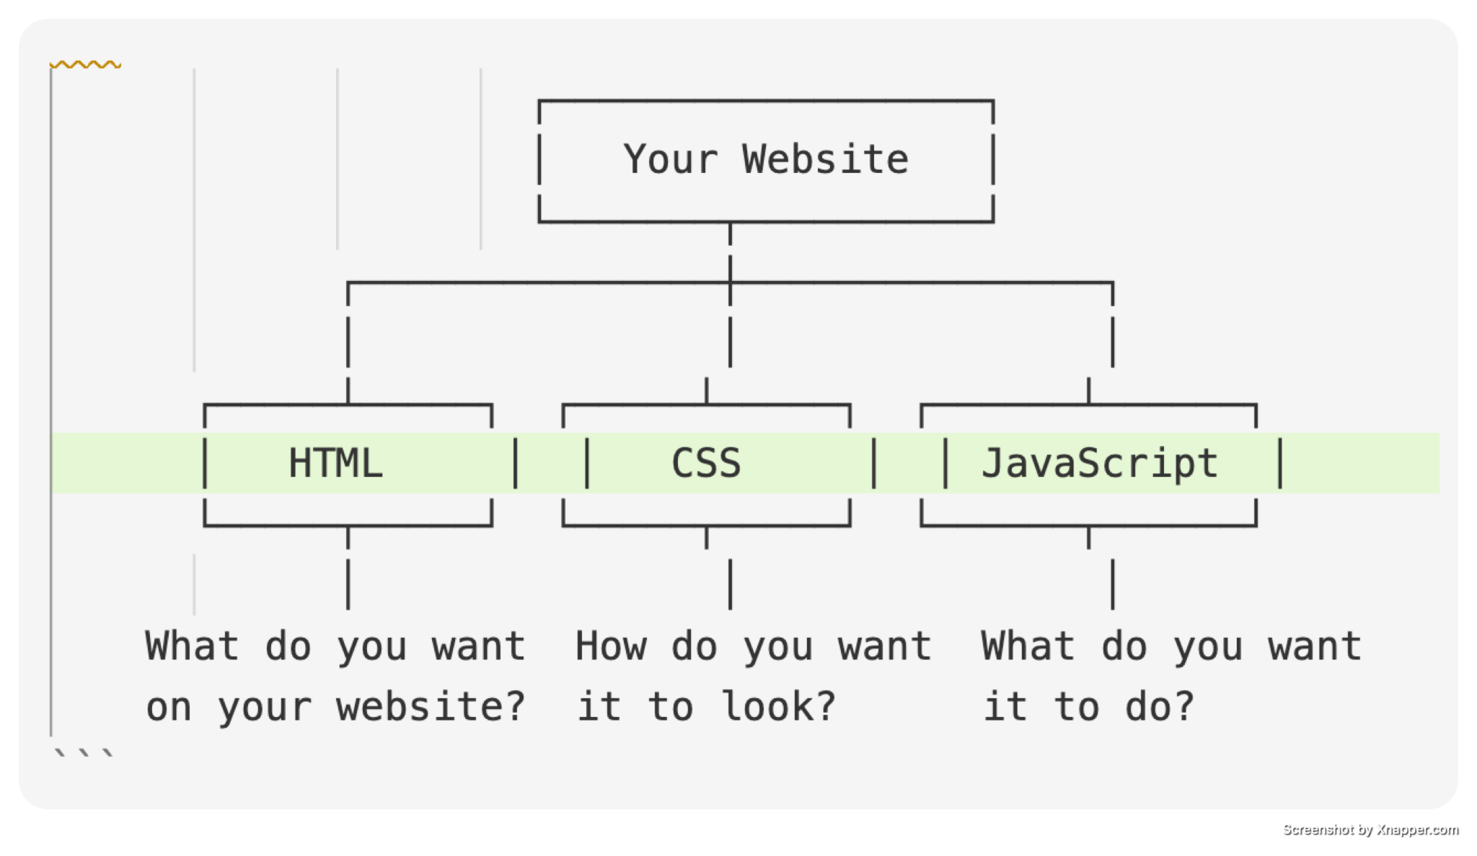
- The DOM: JavaScript can manipulate the Document Object Model (DOM), allowing it to dynamically change a webpage's content, structure, and styling in real time without reloading.
- Asynchronous programming: It supports asynchronous operations through callbacks, Promises, and `async/await`, making it efficient for tasks like API calls and file handling.
- Ecosystem: It has a massive ecosystem of libraries and frameworks such as React, Angular, Vue.js (frontend) and Express, Next.js (backend), supported by the npm package manager.
- Universal adoption: JavaScript is the most widely used programming language in the world, supported by all modern browsers and backed by a huge developer community.

✅ Is JavaScript Compiled or Interpreted?
JavaScript is an interpreted language with JIT compilation at runtime.

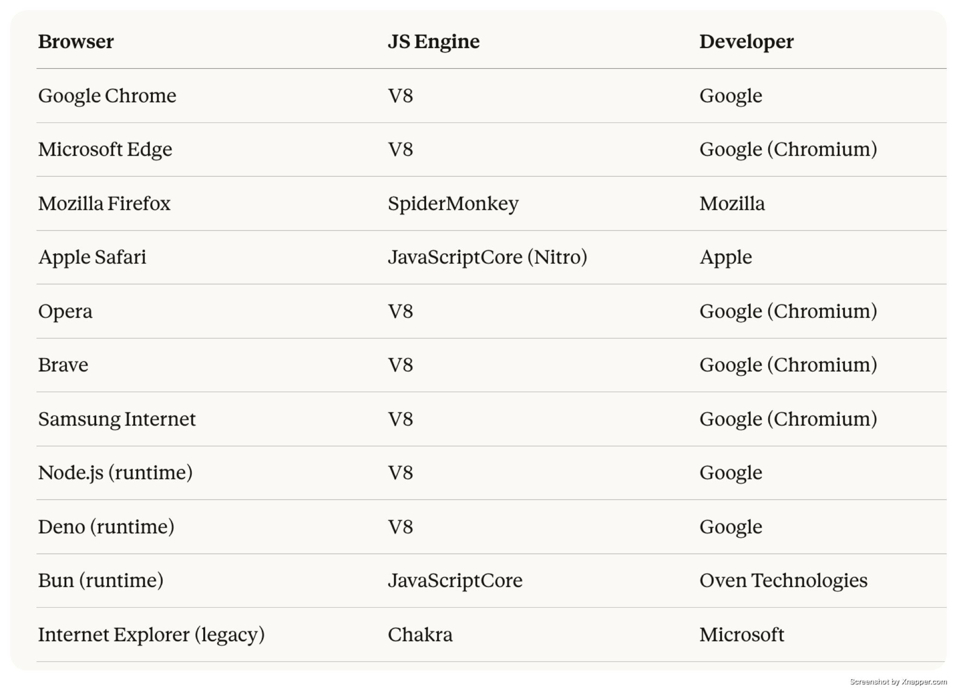

✅ JavaScript: Compile-Time & Runtime?

- JavaScript is Primarily a Runtime (Interpreted) Language Traditionally, JavaScript code is executed line by line at runtime by the browser's JS engine.
- There's no separate compilation step like in C++ or Java.
- Simple Terms - JavaScript is a runtime language that uses JIT compilation internally for performance.
- So it's not compiled ahead of time like C++, but it's not purely interpreted either it sits somewhere in between.

✅ What is Node.js?

- Node.js is an open-source, cross-platform JavaScript runtime environment that allows you to run JavaScript code outside of a web browser primarily on servers.
- It was created by Ryan Dahl in 2009 and is built on Google Chrome's V8 JavaScript engine.

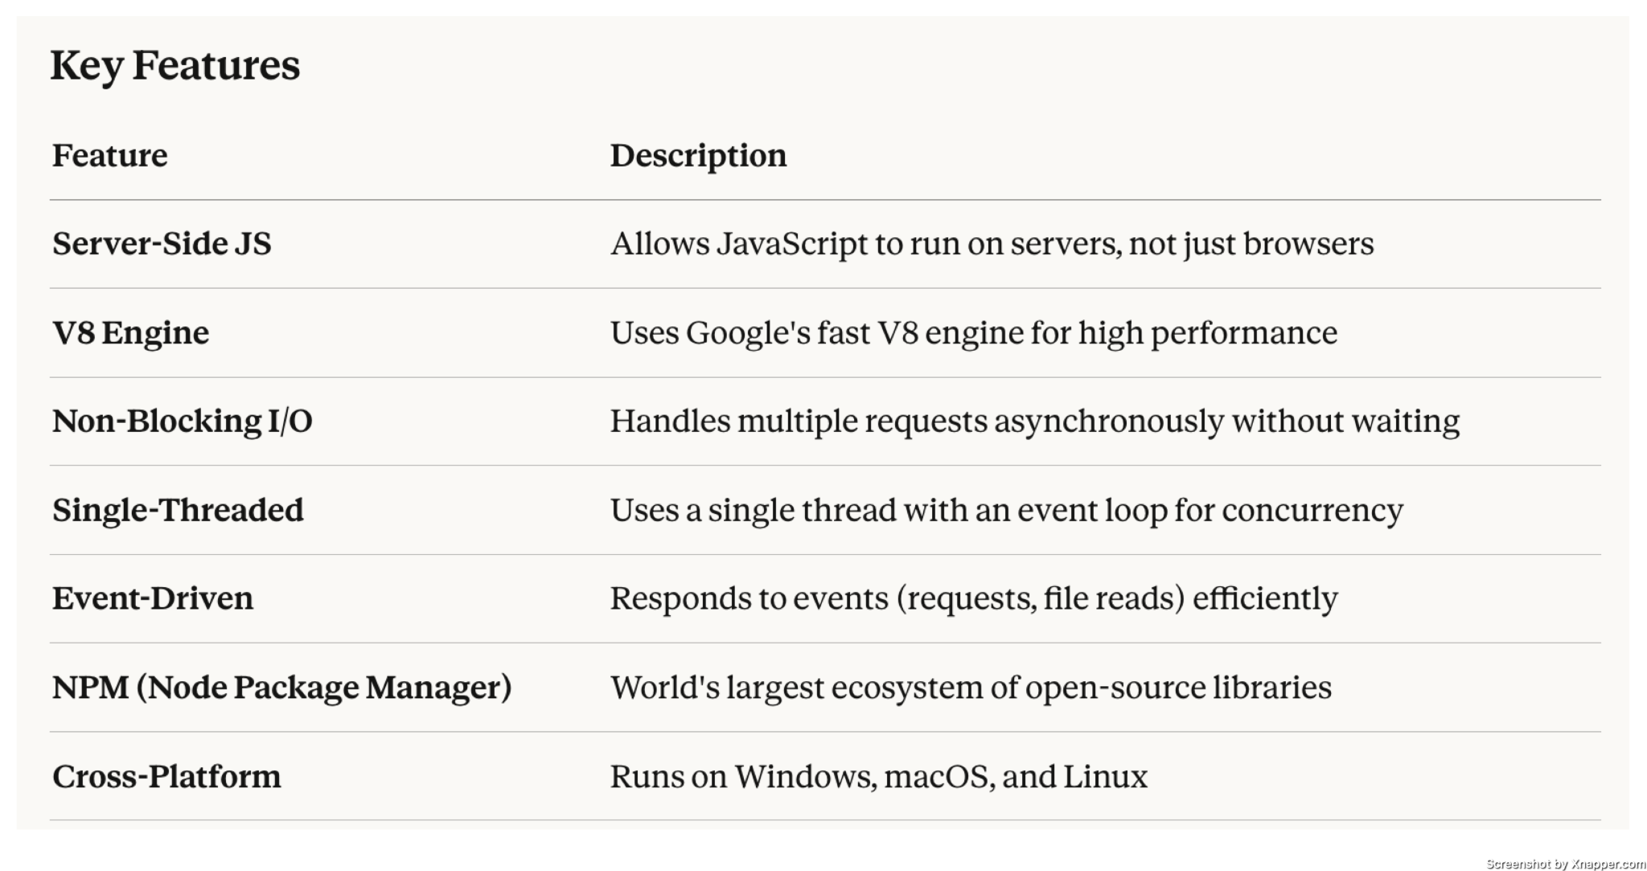
Common Use Cases
  - Web Servers & APIs (REST, GraphQL)
  - Real-Time Apps (Chat apps, live notifications)
  - Microservices Architecture
  - Command-Line Tools (CLI apps)
  - Streaming Applications (Video/audio)
  - IoT (Internet of Things)

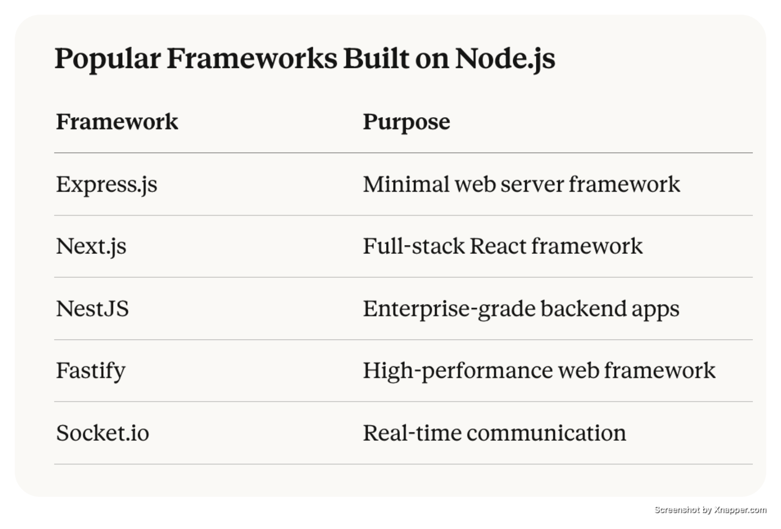

🟩 NODE js in simple terms

Node.js = JavaScript + V8 Engine + Server-Side Capabilities, enabling full-stack development using a single language.

🟩 Install Visual Studio Code

Visual Studio Code, and adding Node.js to the environment variables for Windows, macOS, and Linux.

Install Node.js

Windows:
1. Download the Windows installer from the [Node.js website](https://nodejs.org/).
2. Run the installer.
3. Follow the prompts in the installer (Accept the license agreement, click the NEXT button a bunch of times and finally install).
4. Restart your computer to ensure changes take effect.

MacOS:
1. Download the macOS installer from the [Node.js website](https://nodejs.org/).
2. Open the `.pkg` file you downloaded and follow the instructions.
3. You may need to enter your admin password.
4. To verify installation, open a terminal and type `node -v`.

Linux
1. Use a package manager to install Node.js.
- For Ubuntu/Debian, use `sudo apt-get install nodejs npm`.
- For Fedora, use `sudo dnf install nodejs`.
- For other distributions, check the package manager or Node.js website.
2. Verify the installation with `node -v` and `npm -v`.

🟩 Install VS Code - Visual Studio Code (

Windows, macOS, and Linux:
1. Go to the VS Code website, https://code.visualstudio.com
and download the installer for your OS.
2. Run the installer.
3. Follow the installation instructions.
4. Launch VS Code after installation.

🟩 Adding Node.js to the Environment Variables

Windows:

1. Search for "Environment Variables" in the Start menu and open "Edit the system environment variables."
2. Click on "Environment Variables."
3. Under "System Variables," find the "Path" variable and click "Edit."
4. Click "New" and add the path to your Node.js installation (usually C:\Program Files\nodejs).
5. Click OK to save your changes.

macOS and Linux:

1. Open your terminal.
2. Edit your shell profile file (.bash_profile, .bashrc, .zshrc, etc.). For bash, use nano ~/.bash_profile or nano ~/.bashrc. For zsh, use nano ~/.zshrc.
3. Add export PATH="/usr/local/share/npm/bin:$PATH" to your profile (adjust the path if your Node.js installation is different).
4. Save the file and reload your profile with source ~/.bash_profile, source ~/.bashrc, or source ~/.zshrc.
Install Code Runner
https://open-vsx.org/extension/formulahendry/code-runner

ESLint : Catches errors and enforces clean code
https://marketplace.visualstudio.com/items?itemName=dbaeumer.vscode-eslint

Prettier : Auto-formats your code perfectly
https://marketplace.visualstudio.com/items?itemName=esbenp.prettier-vscode

Live Server : Live reload for instant browser preview
https://marketplace.visualstudio.com/items?itemName=ritwickdey.LiveServer

Error Lens : Shows errors/warnings directly in your code
https://marketplace.visualstudio.com/items?itemName=usernamehw.errorlens

JavaScript (ES6) : Code Snippets Speeds up coding with ready-made snippets
https://marketplace.visualstudio.com/items?itemName=xabikos.JavaScriptSnippets

🟩 How JavaScript Engine Works
A JavaScript engine is a program that reads, interprets, and executes JavaScript code. Here's a complete breakdown of how it works step by step.

Overview Flow
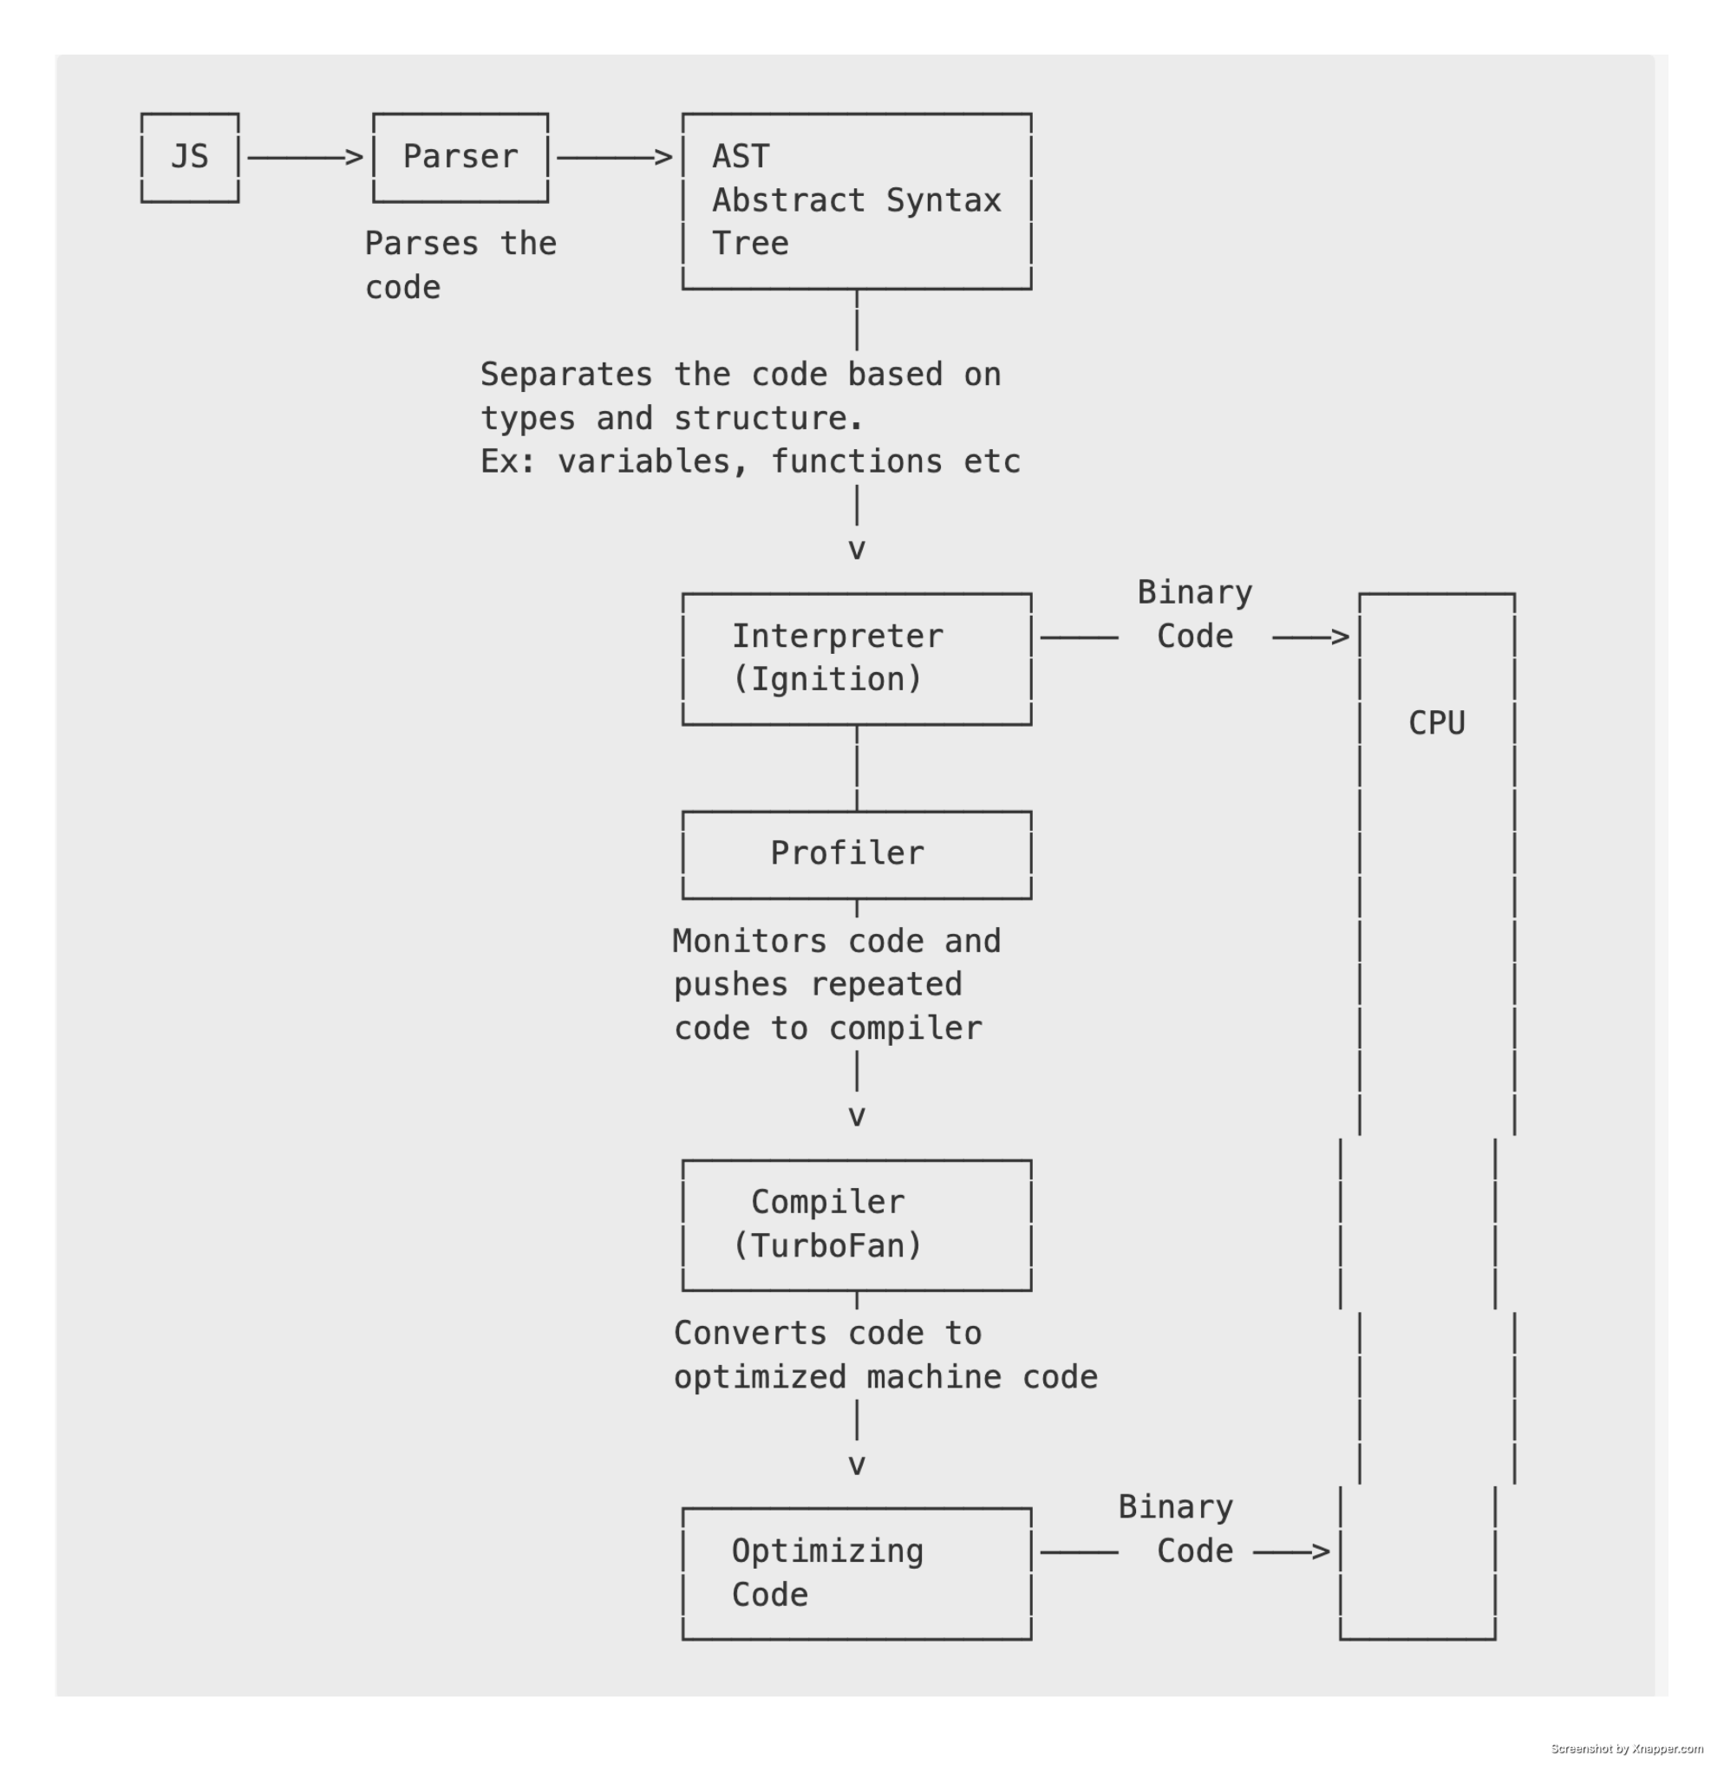

🟩 Step-by-Step Breakdown

1. Lexical Analysis (Tokenizing)
The engine first breaks the raw code into small meaningful chunks called tokens.
Example: let x = 10;
Tokens → [let] [x] [=] [10] [;]

2. Parsing (Syntax Analysis)
The tokens are then organized into a tree-like structure called an Abstract Syntax Tree (AST). This represents the grammatical structure of the code.
Program
|
VariableDeclaration
/ \
Identifier Literal
(x) (10)

If there's a syntax error, it gets caught at this stage.

3. Interpreter (Generates Bytecode)
The AST is passed to the interpreter, which converts it into bytecode — a lower-level, platform-independent code that the engine can execute quickly.This allows fast startup since the code doesn't need to be fully compiled first.
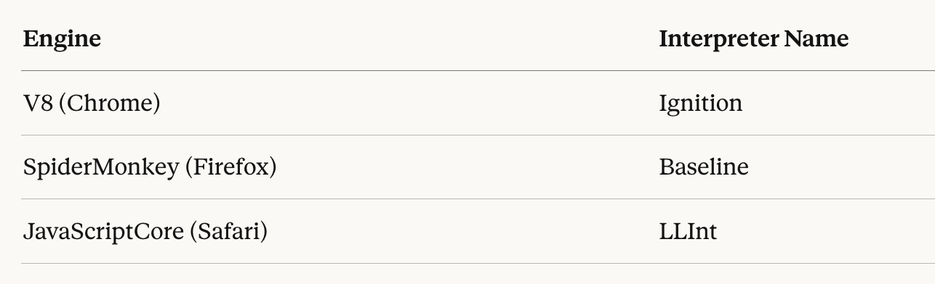

4. Execution
The bytecode is executed immediately. At this point, your JavaScript code is running.

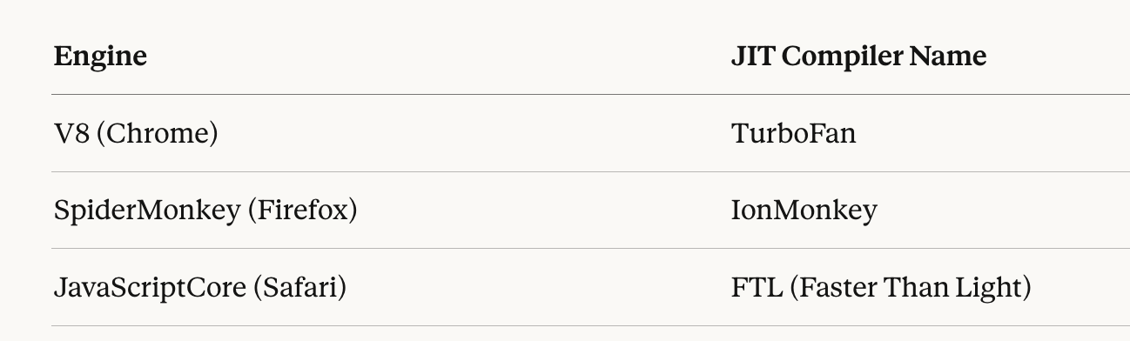

5. JIT Compilation (Optimization)
While the code runs, the engine monitors which parts of the code are used frequently (called "hot code").
The JIT (Just-In-Time) Compiler takes that hot code and compiles it into highly optimized machine code for faster execution.

6. De-optimization
If the engine's assumptions about the code turn out to be wrong (for example, a variable's type changes unexpectedly), it de-optimizes — throws away the optimized machine code and falls back to the bytecode version.
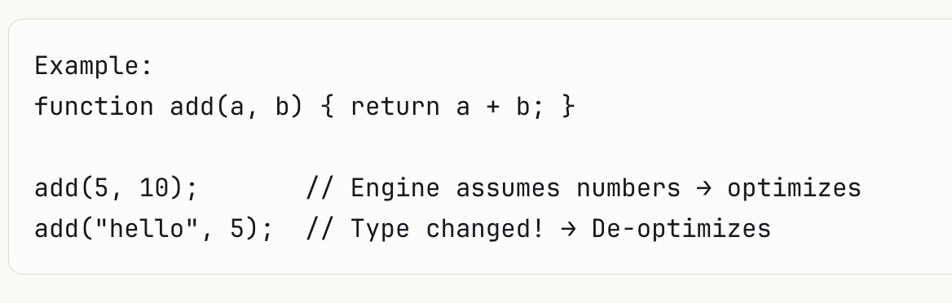

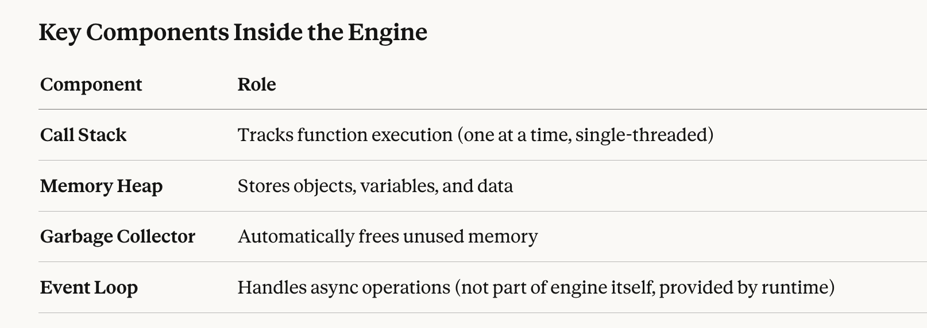

Summary
The JavaScript engine parses your code into a tree, interprets it into bytecode for quick execution, and then JIT compiles frequently used code into optimized machine code for maximum speed. If assumptions fail, it de-optimizes and falls back.

🟩 How does a V8 engine Works?
V8 is Google's open-source high-performance JavaScript and WebAssembly engine, written in C++. It powers Google Chrome and Node.js.
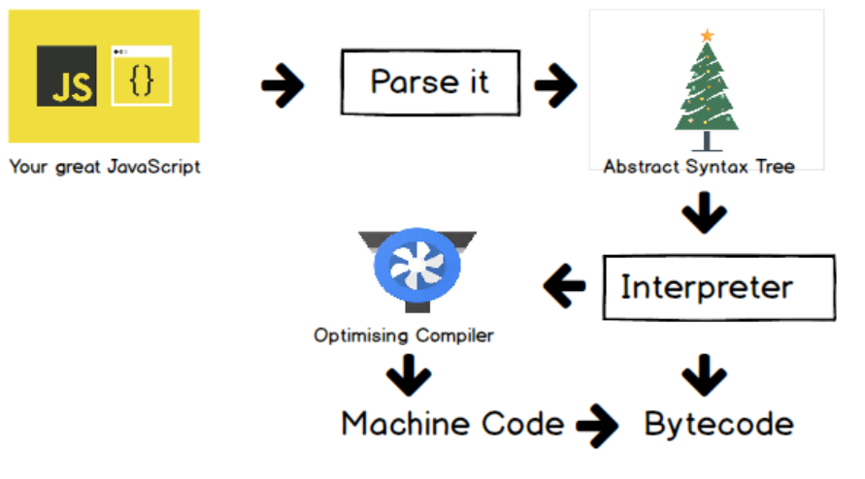
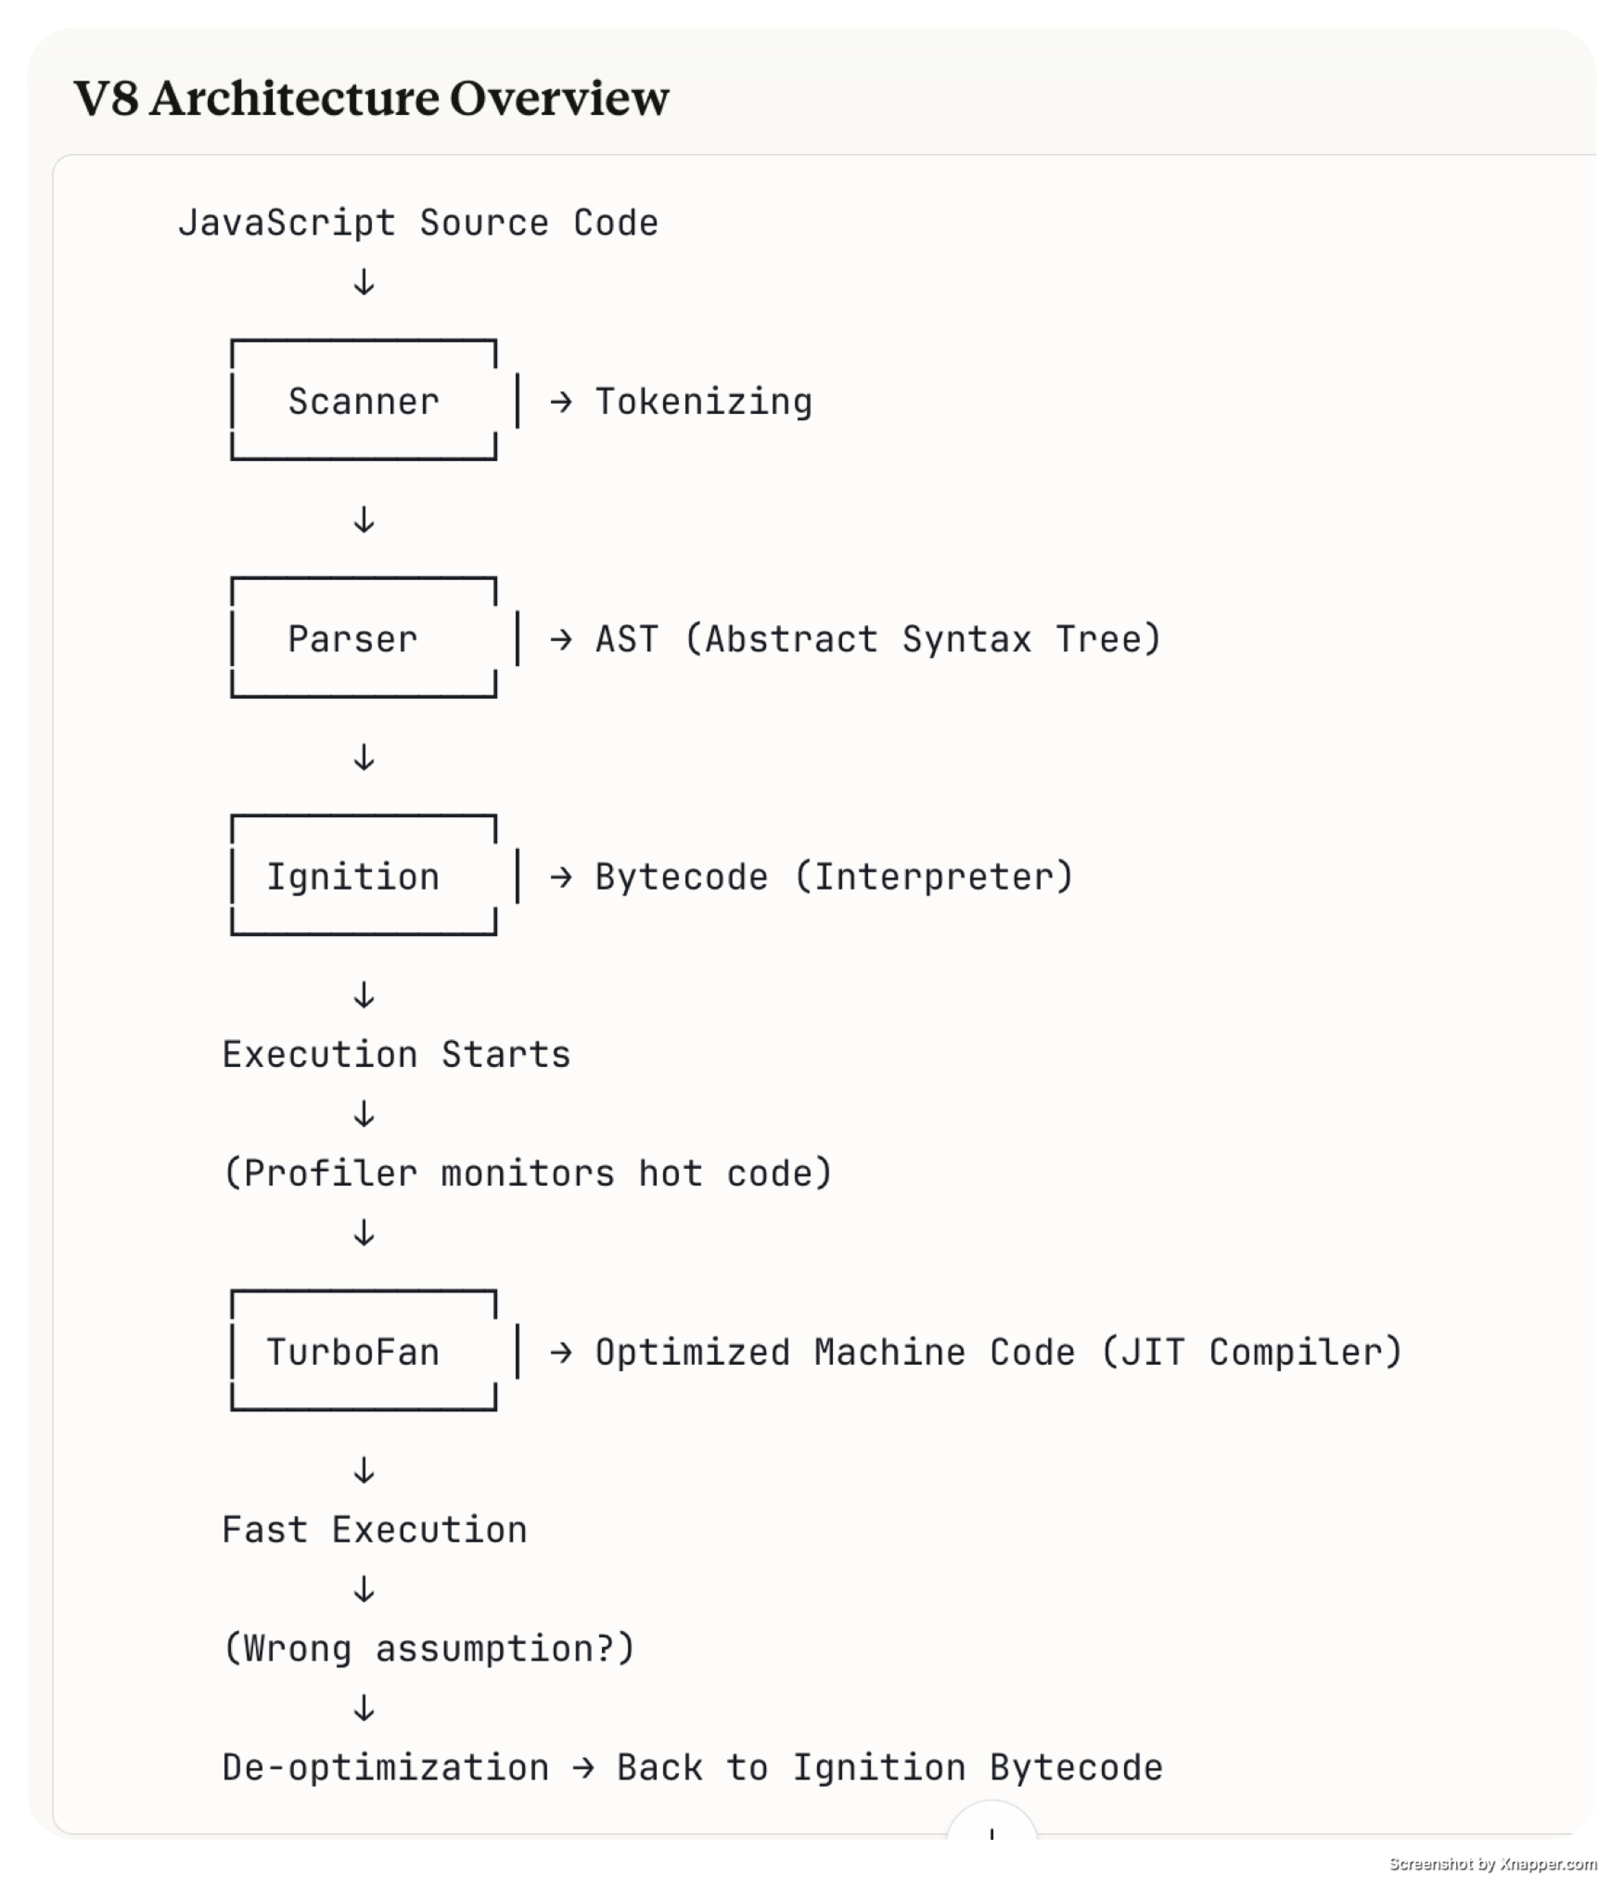

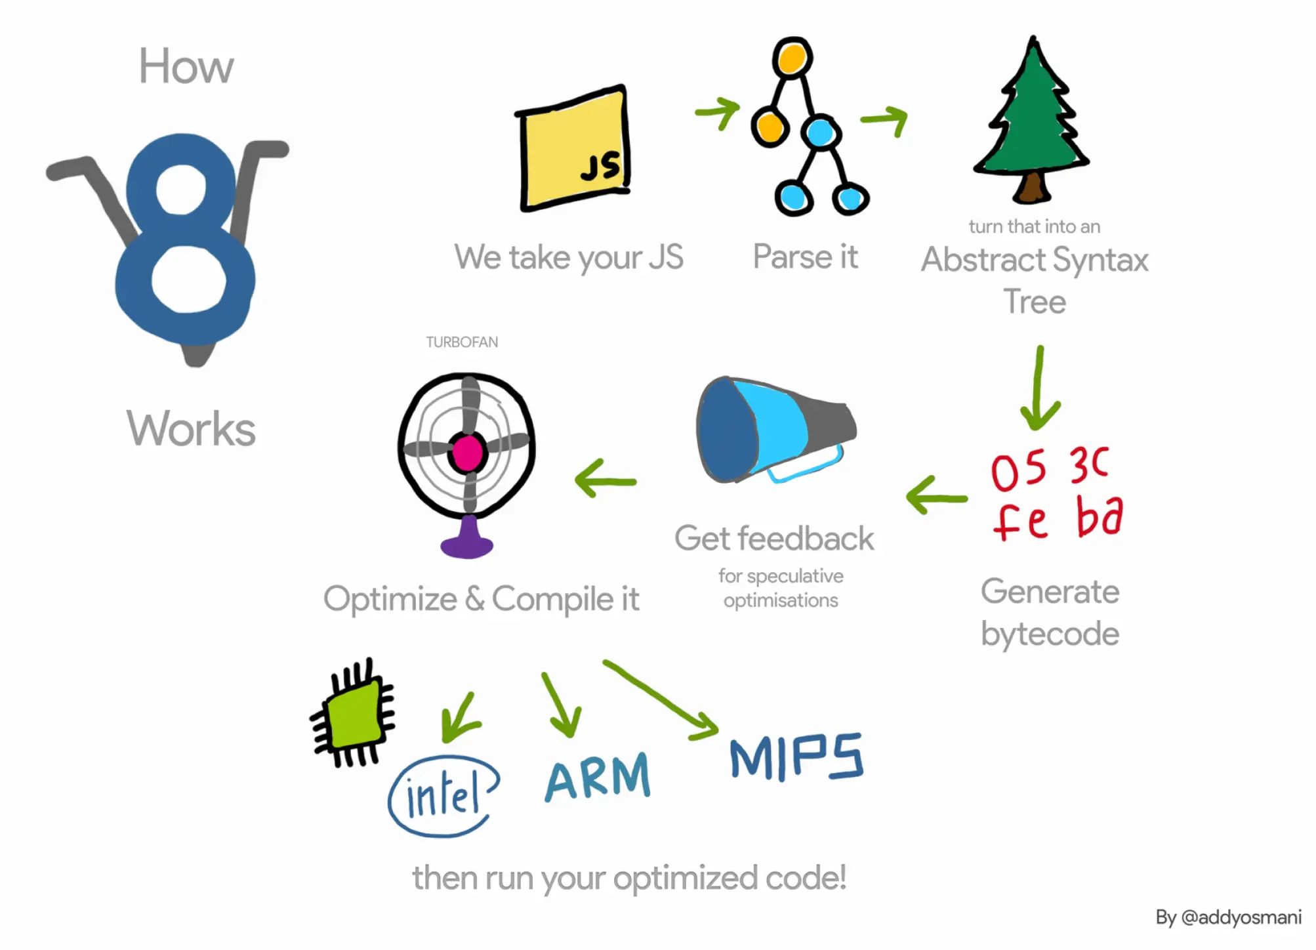

Step-by-Step Breakdown

Step 1: Scanner (Lexical Analysis / Tokenizing)
The scanner reads your raw JavaScript code character by character and breaks it into tokens.
Source: const sum = 10 + 20;

Tokens: [const] [sum] [=] [10] [+] [20] [;]
It also handles lazy parsing — meaning it skips parsing functions that aren't immediately needed to improve startup speed.

Step 2: Parser (Syntax Analysis)
The parser takes the tokens and builds an Abstract Syntax Tree (AST).
V8 uses two parsers for performance:

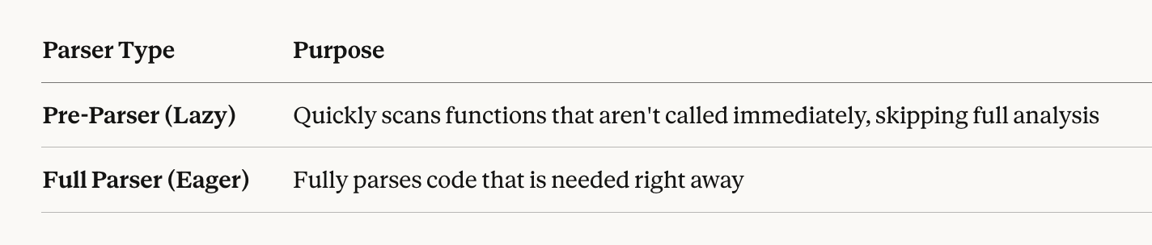

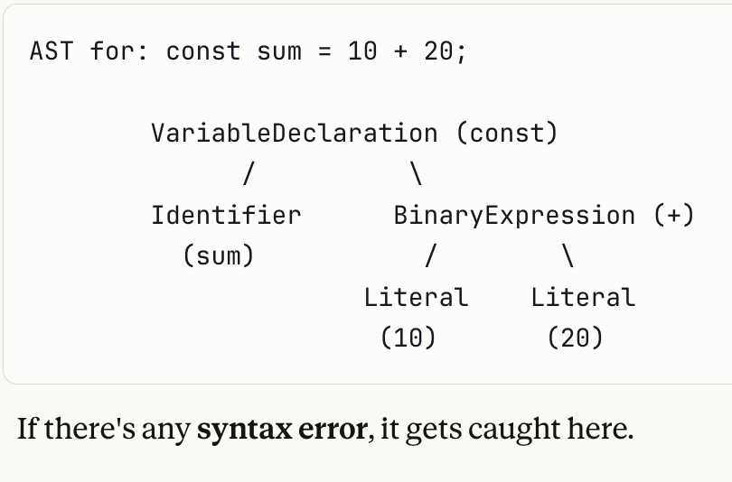

Step 3: Ignition (Interpreter)
Ignition is V8's interpreter. It takes the AST and converts it into bytecode.

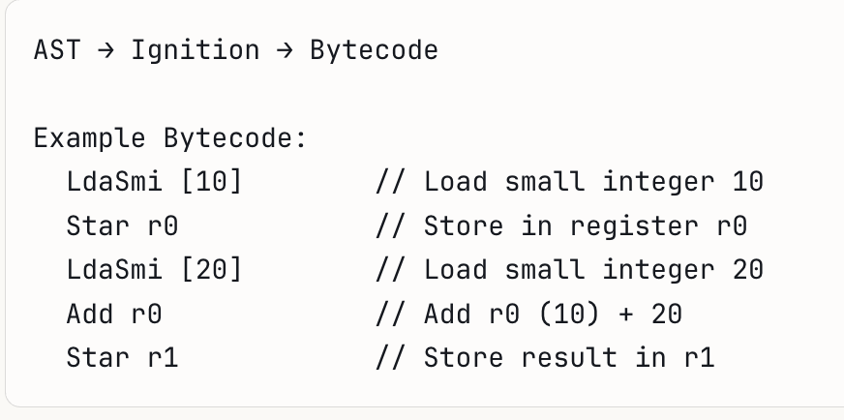

Why bytecode? Bytecode is smaller than machine code, uses less memory, and allows faster startup compared to compiling everything upfront.
Ignition also collects feedback data (type information, frequency of execution) while executing bytecode. This data is critical for the next step.

Step 4 : Execution + Profiling
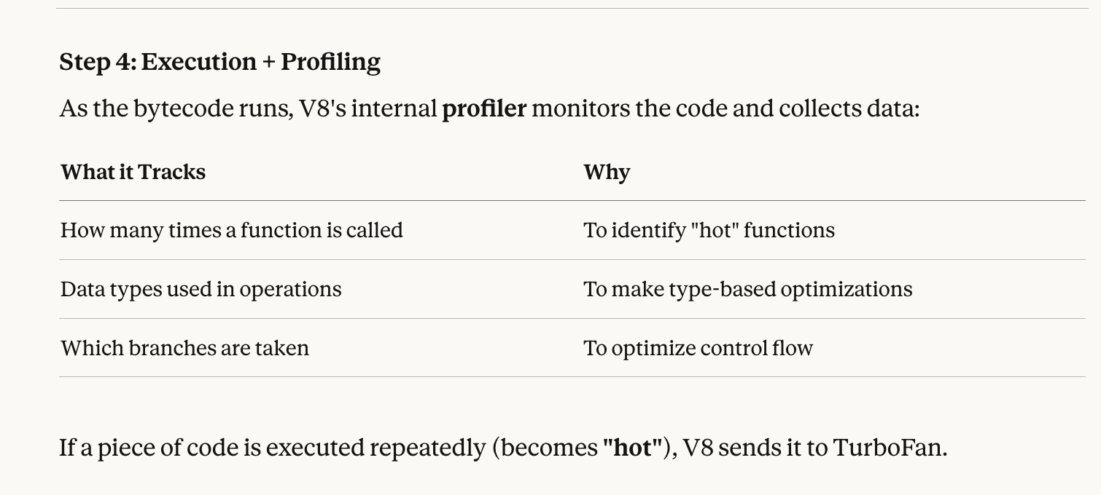

Step 5 : TurboFan (JIT)

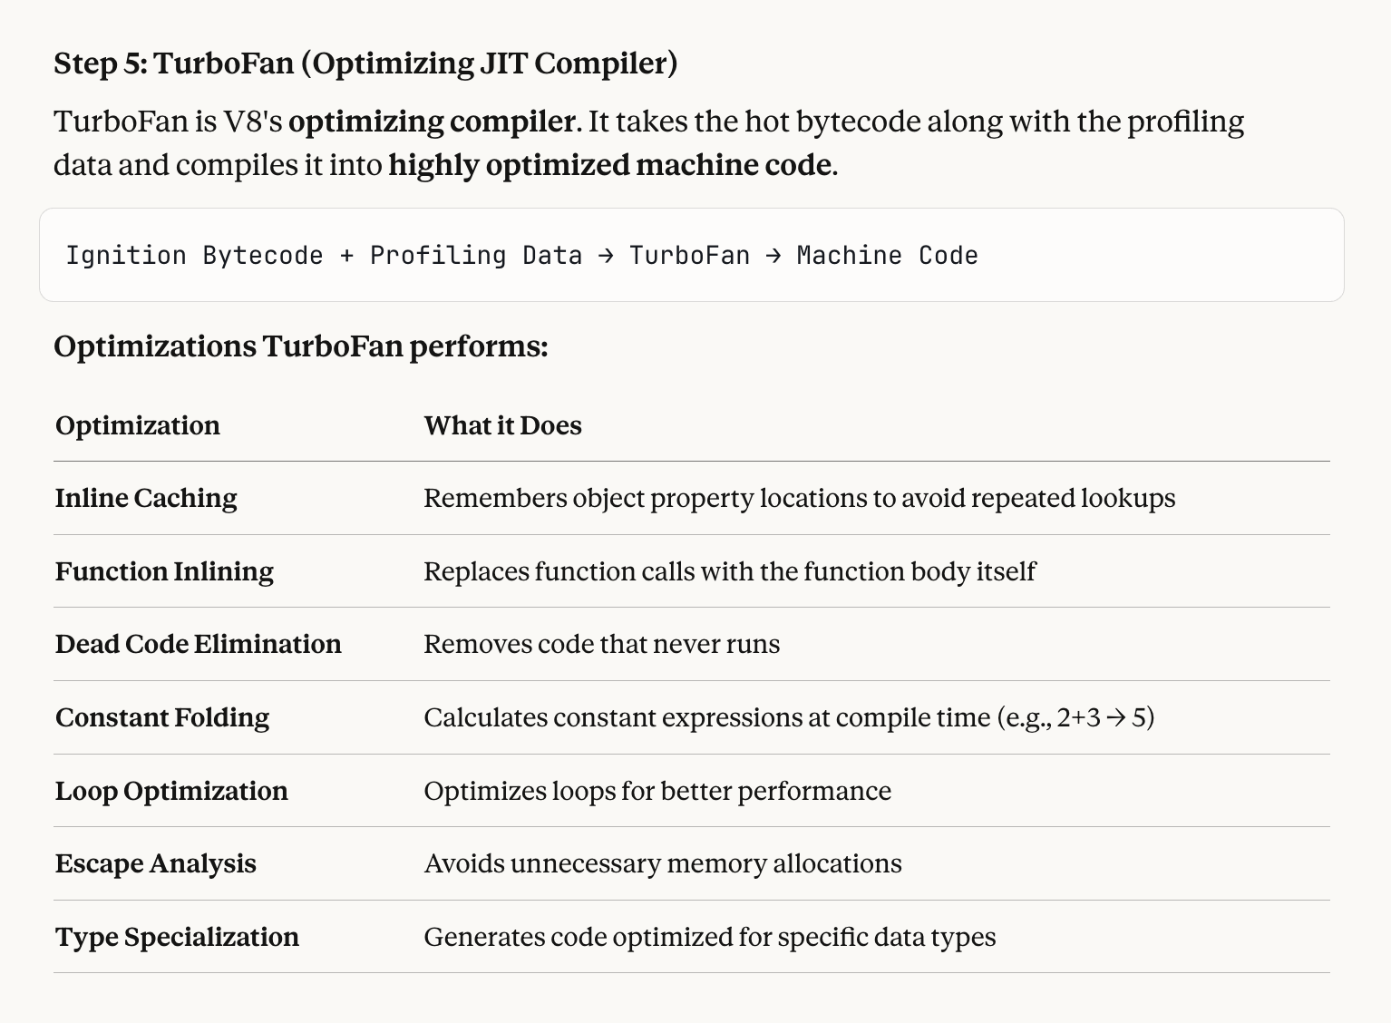

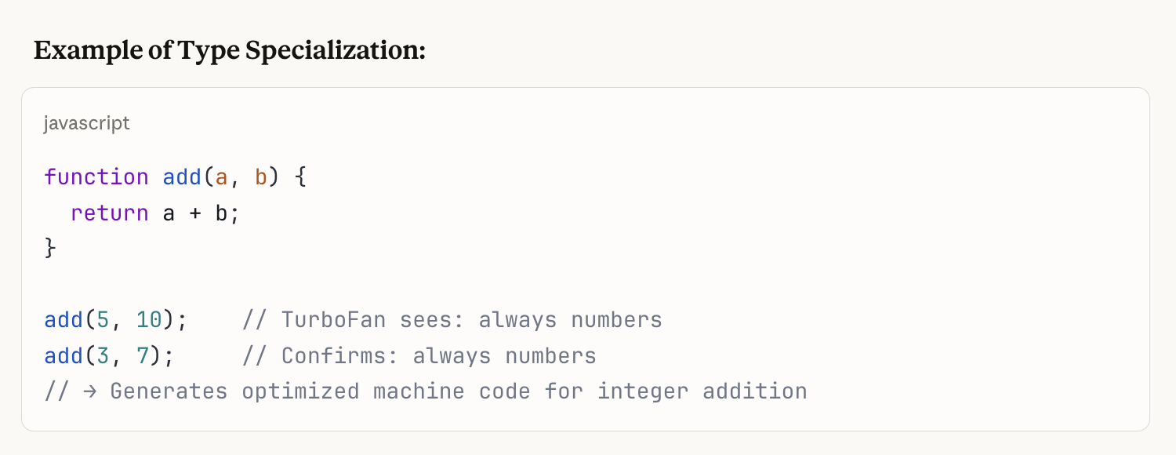

Step 6: De-optimization (Bailout)
If TurboFan's assumptions turn out to be wrong, V8 throws away the optimized machine code and falls back to Ignition's bytecode.
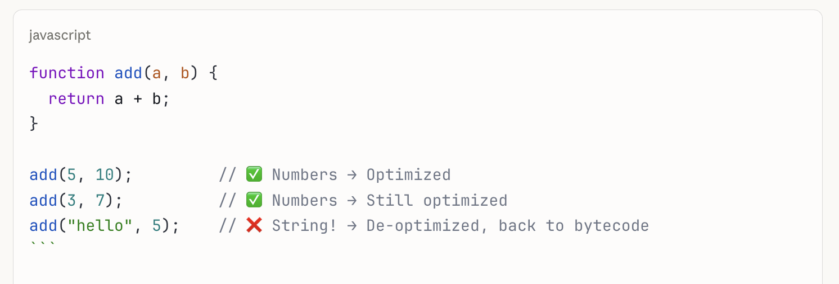.

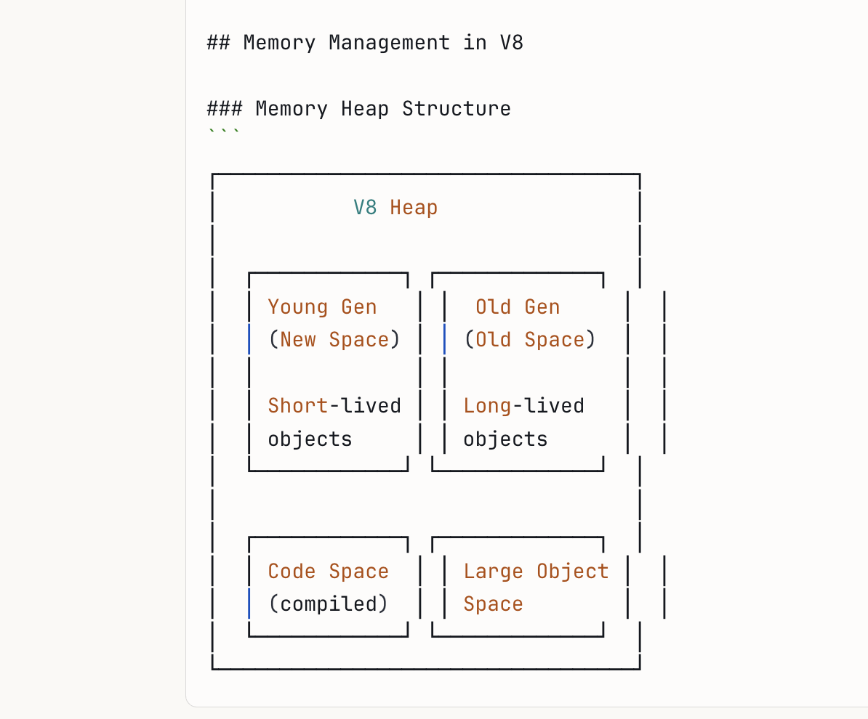

Step 7: Garbage Collection:
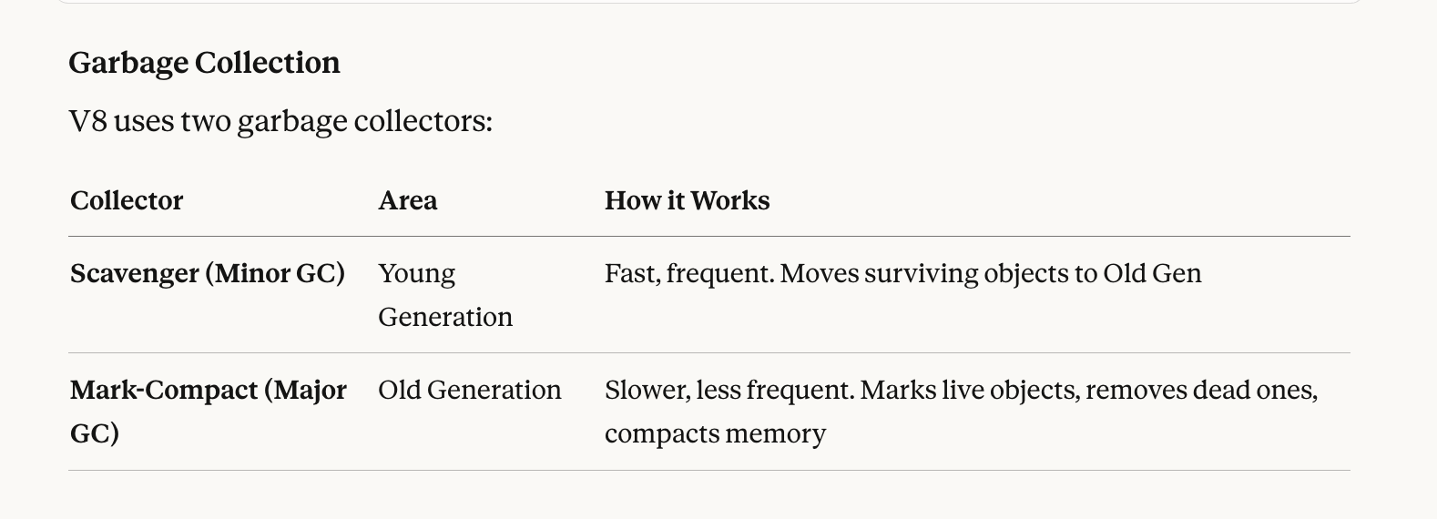

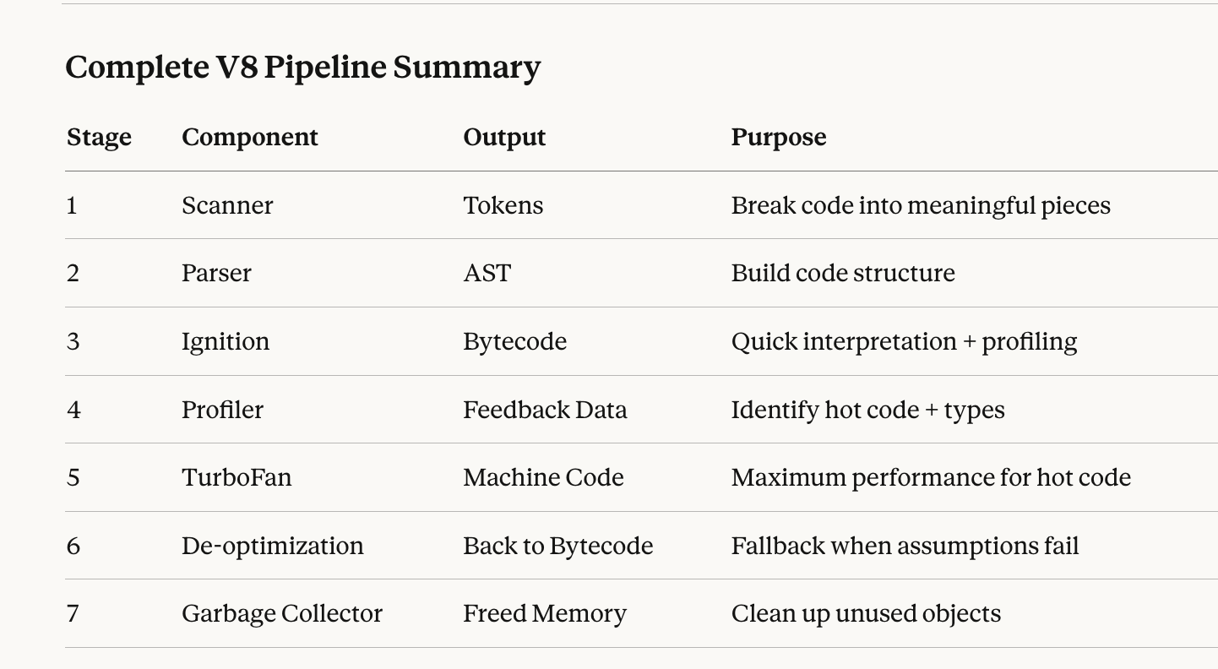

V8 takes your JavaScript, parses it into an AST, interprets it to bytecode via Ignition for fast startup, then JIT compiles hot code via TurboFan into optimized machine code, while managing memory through generational garbage collection and speeding up property access with hidden classes and inline caching.



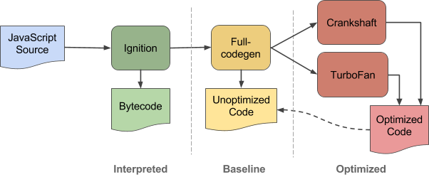

Reference Article

- https://dev.to/laxminarayana31/how-javascript-really-works-1p6i
- https://v8.dev/blog/ignition-interpreter
- https://medium.com/@manikmudholkar831995/the-v8-javascript-engine-d1434ca77c96
- https://v8.dev/

ECMAScript Standard

What is ECMAScript?
ECMAScript (ES) is the official standard/specification that defines how JavaScript should work. Think of it as the rulebook that JavaScript follows.
It is maintained by ECMA International under the specification name ECMA-262, and developed by a committee called TC39 (Technical Committee 39).
In simple terms:
- ECMAScript tells WHAT JavaScript should do
- JavaScript is HOW it's actually done in browsers and engines
- ES6 (ES2015) — The Game Changer
ES6 was the most important update in JavaScript history.

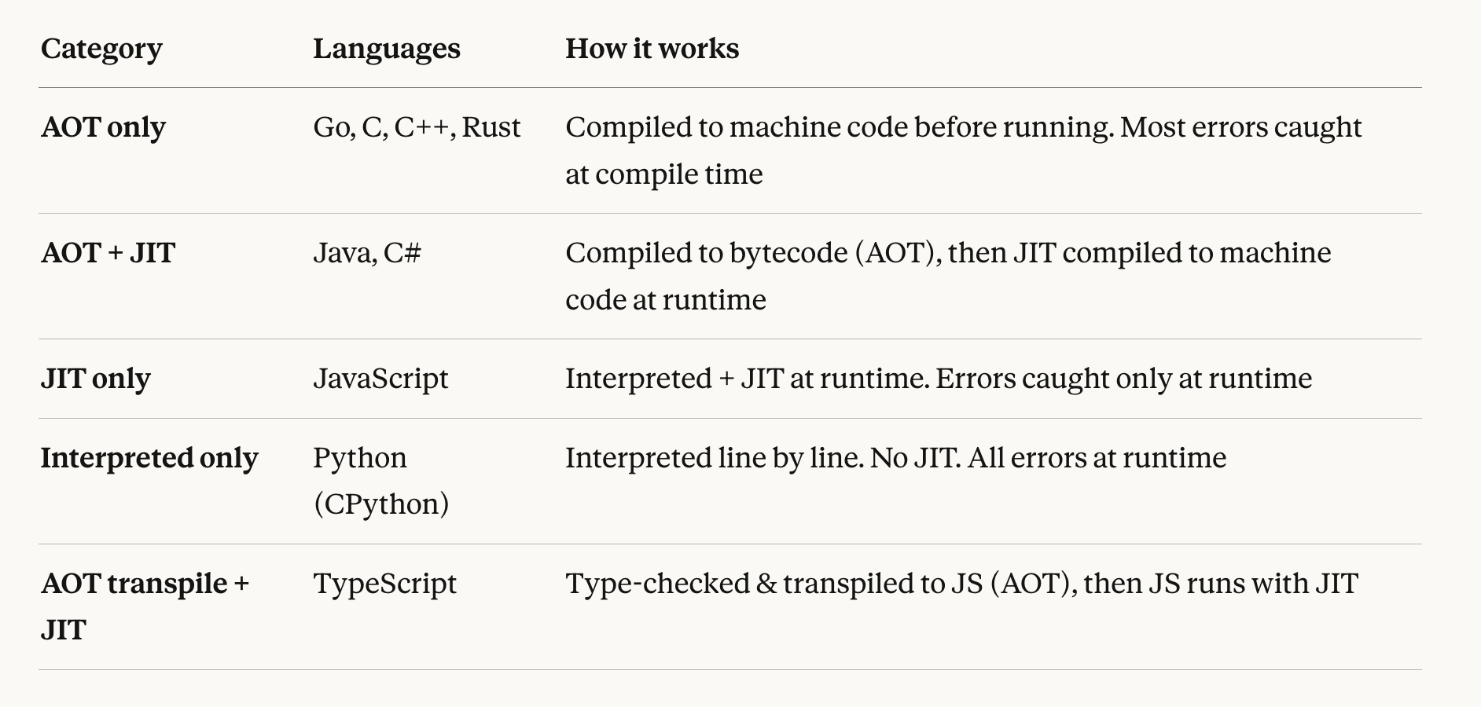

Node –trace-opt file.js
- Simple hell
- For loop

Chapter 02: Variables (var, let, const)

🟩 Variables in JavaScript: Comments, Identifiers, Keywords, Literals, var, let, const

🟩 What are Variables?
Variables are containers for storing data values. In JavaScript, we have three ways to declare variables:
- var → Function Scoped (old way, ES5)
- let → Block Scoped (modern, ES6+)
- const → Block Scoped + Cannot be reassigned (modern, ES6+)

🟩 Comments in JavaScript
Comments are lines of code that will not be executed by the JavaScript engine. They are used to explain the code, make it more readable, or temporarily disable code.

Single Line Comment
Use // to write a single line comment. Everything after // on that line is ignored.
// This is a comment. This code will not be executed
console.log("Hello");

Multi Line Comment
Use /* */ or /** */ to write multi-line comments. Everything between the opening and closing is ignored.
/**
* This is multi line
* Author : Pramod Dutta
* Date : 14-Feb-2026
**/

/*
* This is multi line
* Author : Pramod Dutta
* Date : 14-Feb-2026
*/

When to use Comments
- To explain what the code does
- To add author and date information
- To temporarily disable code during debugging
- To write documentation for functions and modules

🟩 Identifier, Literal, and Operator
Every line of JavaScript code is made up of these basic building blocks. Let us understand each one.
var a = 10;

In the above line:
- Identifier → a (the name given to the container/variable)
- Literal → 10 (the actual value stored)
- Operator → = (assignment operator)
- Keyword → var (reserved word that tells JavaScript to create a variable)

Chapter 03: Identifiers, Literals & Operators

🟩 What is a Keyword?
A keyword is a reserved word in JavaScript that has a special meaning. You cannot use keywords as variable names.
Examples of Keywords: var, let, const, function, if, else, for, while, return, class, import, export, new, this, typeof, null, undefined, true, false
// var is a keyword, a is an identifier, 10 is a literal
var a = 10;

🟩 What is a Literal?
A literal is a fixed value that is directly written in the code. It represents the actual data.
Examples of Literals:
- Number Literal → 10, 20, 3.14
- String Literal → "Hello", "Pramod"
- Boolean Literal → true, false
- Null Literal → null
- Undefined Literal → undefined
var a = 10; // 10 is a Number Literal
var name = "Hello"; // "Hello" is a String Literal
var flag = true; // true is a Boolean Literal

🟩 What is an Identifier?
An identifier is the name given to a variable, function, class, or any other user-defined item. Think of it as the name of the container that holds the value.
var a = 10;
a = 20;
console.log(a);
// a is the Identifier (name of the container)
// 10 and 20 are the Literals (values)

🟩 Rules of Identifier
There are strict rules for naming identifiers in JavaScript:
- Must start with a letter, underscore _, or dollar sign $
- Can contain letters, numbers, underscores, and dollar signs
- Cannot start with a number
- Cannot be a reserved keyword
- Cannot contain spaces
- Cannot contain special characters other than underscore and dollar sign
- Identifiers are case sensitive (NAME and name are different)

Valid Identifier Examples
var name = "Hello";
console.log(name);

var $name = "Hello";
console.log($name);

var _name = "Hello";
console.log(_name);

var name1 = "Hello";
console.log(name1);

var name_1 = "Hello";
console.log(name_1);

var name$1 = "Hello";
console.log(name$1);

var name_1$1 = "Hello";
console.log(name_1$1);

var name_1$1_2 = "Hello";
console.log(name_1$1_2);

Case Sensitivity Example
var NAME = "pramod";
var name1 = "dutta";
console.log(NAME); // pramod
console.log(name1); // dutta
// NAME and name1 are two completely different variables

Unicode Identifiers (Yes, JavaScript supports them!)
JavaScript allows Unicode characters in identifiers. So you can use characters from other languages too.
var π = 3.14;
console.log(π); // 3.14

var नमस्ते = "Hi";
console.log(नमस्ते); // Hi

var _ = "Hello";
console.log(_); // Hello

These are valid but not recommended for production code. Stick to English letters for readability and team collaboration.

🟩 var (Function Scoped)
var is the oldest way to declare variables in JavaScript. It is function scoped, meaning it is accessible anywhere inside the function where it is declared. It does NOT respect block scope (like if, for blocks).

Example 1: Global Scope
var a = 10; // Global Scope
console.log(a); // 10

Example 2: var inside a Function
// Definition of the function
function printHello(){
console.log("Hello TheTestingAcademy!");
var a = 20; // Local Scope
console.log(a); // 20

if(true){
var a = 30;
console.log(a); // 30
}

console.log("F ->", a); // 30
}

// Calling of the function
printHello();

Why does console.log("F ->", a) print 30?
Because var is function scoped, not block scoped. The var a = 30 inside the if block is the same variable as var a = 20 in the function. It overwrites it. There is no separate block scope for var.

Example 3: var allows Re-declaration
// var also allows re-declaration:
var a = 10;
var a = 20; // No error, re-declaration is allowed
console.log(a); // 20

Key Points about var
- var is function scoped
- Inside an if block, var a = 30 overwrites the same a in the function scope
- var allows re-declaration in the same scope without any error
- var declarations are hoisted to the top of their scope

🟩 let (Block Scoped)
let was introduced in ES6 (ES2015). It is block scoped, meaning it only exists inside the block {} where it is declared. Each block gets its own separate copy of the variable.

Example 1: Global Scope
let b = 20; // Global Scope
console.log(b); // 20

Example 2: let inside a Function
// Defination of the function
function printHello(){
console.log("Hello TheTestingAcademy!");
let b = 30; // Local Scope
console.log(b); // 30

if(true){
let b = 5;
console.log(b); // 5
}

console.log("let ->", b); // 30
}

// Calling of the function
printHello();

Why does console.log("let ->", b) print 30?

// SCOPE REFERENCE: let
// let is block-scoped {}. A variable declared inside a block
// is distinct from one outside, even with the same name.

Example 3: let does NOT allow Re-declaration in the same scope

/**
* Example 3: Re-declaration Check
* let DOES NOT allow re-declaration in the same scope.
*/
let b = 30;
// let b = 40; // SyntaxError: Identifier 'b' has already been declared

Example 4: let allows Reassignment

/**
* Example 4: Reassignment Check
* let ALLOWS reassignment (mutable value).
*/
let a = 10;
a = 20; // Valid reassignment
console.log(a); // Output: 20

Example 5: Cannot mix var and let for the same name

/**
* Example 5: Namespace Conflicts
* Cannot mix 'var' and 'let' for the same identifier.
*/
var nn = "Pramod";
// let nn = "Pramod"; // Error: Identifier 'nn' has already been declared

Key Points about let

/**
* TECHNICAL SUMMARY: let
* - Scope: Block scoped (if, for, while, {})
* - Shadowing: Each block gets a unique instance
* - Re-declaration: Prohibited in same scope
* - Reassignment: Permitted
* - Hoisting: Hoisted to top of block but uninitialized (TDZ)
*/


🟩 const (Block Scoped + Constant)

/**
* ES6 REFERENCE: const
* Immutable reference. Must be initialized on declaration.
*/
const pi = 3.14;
// pi = 3.14159; // TypeError: Assignment to constant variable

Example 1: Declaring a constant

Key Points about const

/**
* TECHNICAL SUMMARY: const
* - Scope: Block scoped
* - Reassignment: Strictly Prohibited
* - Re-declaration: Strictly Prohibited
* - Initialization: Required at declaration
* - Mutation: Objects/Arrays remain mutable (reference is constant)
*/


var vs let vs const: Quick Comparison
Feature | var | let | const
Scope | Function Scoped | Block Scoped | Block Scoped
Re-declaration | Allowed | Not Allowed | Not Allowed
Reassignment | Allowed | Allowed | Not Allowed
Hoisting | Hoisted + initialized as undefined | Hoisted but NOT initialized (TDZ) | Hoisted but NOT initialized (TDZ)
Must Initialize | No | No | Yes
Introduced In | ES1 (original) | ES6 (2015) | ES6 (2015)

🟩 var vs let: Scope Difference (Visual)
function example() {
// var → Function Scope
// The ENTIRE function is one scope for var

if (true) {
var x = 10; // Same scope as function
let y = 20; // Only inside this if block
}

console.log(x); // 10 (var is function scoped, still accessible)
console.log(y); // Error! (let is block scoped, not accessible here)
}

🟩 When to Use What?
- Use const by default for all variables
- Use let when you know the value will change (counters, flags, reassignments)
- Avoid var in modern JavaScript (it can cause unexpected bugs due to function scoping)
In Simple Terms
const = "I will never change this value"
let = "I might change this value later"
var = "Old way, avoid using it"

Chapter 04: Operators

🟩 Operators in JavaScript
An operator is a symbol that performs an operation on values (called operands). In the expression 10 + 3, the + is the operator and 10 and 3 are the operands. JavaScript groups its operators into a few main types:

// CHEAT SHEET: Operators
const operators = {
arithmetic: ["+", "-", "*", "/", "%", "**"],
assignment: ["=", "+=", "-=", "*=", "/=", "%="],
comparison: ["==", "===", "!=", "!==", ">", "<", ">=", "<="],
logical: ["&&", "||", "!"],
string: ["+"],
ternary: ["condition ? val1 : val2"],
type: ["typeof"],
nullish: ["??"]
};

🟩 Arithmetic Operators
Arithmetic operators perform basic math. Let us take two variables and try each one.

// MODULE: Arithmetic Operations
let a = 10, b = 3;
console.log(a + b); // Addition: 13
console.log(a - b); // Subtraction: 7
console.log(a * b); // Multiplication: 30
console.log(a / b); // Division: 3.33...
console.log(a % b); // Modulus (Remainder): 1
console.log(a ** b); // Exponentiation: 1000

🟩 Assignment Operators
The = operator assigns a value to a variable. JavaScript also gives you compound assignment operators, which do a calculation and assign the result back to the same variable in one short step.

// LOGIC: Conditionals (if/else)
/**
* TRUTHY: non-empty string, non-zero num, {}, []
* FALSY: "", 0, null, undefined, NaN, false
*/
function evaluate(val) {
if (val) {
return "Truthy - Block Executes";
} else {
return "Falsy - Block Skipped";
}
}

Operator | Example | Same As
+= | x += 10 | x = x + 10
-= | x -= 3 | x = x - 3
*= | x *= 2 | x = x * 2
/= | x /= 4 | x = x / 4
%= | x %= 4 | x = x % 4

🟩 Comparison Operators
A comparison operator compares two values and always returns a boolean (true or false). These are the backbone of every if condition you will ever write. First understand the three kinds of "equals":

- = is the Assignment operator (puts a value into a variable)
- == is Loose comparison (checks the value only, ignores the data type)
- === is Strict comparison (checks the value AND the data type)

Think of it like comparing two people. == is a loose match ("both are human"). === is a strict match ("same religion, same language, same city"), everything has to match.

console.log(3 > 4); // false

console.log(3 < 4); // true

console.log(4 >= 4); // true (4 > 4 OR 4 === 4, an OR check)

console.log(3 <= 4); // true

console.log(5 == "5"); // true (loose: value matches, type ignored)

console.log(5 === "5"); // false (strict: number vs string, type differs)

console.log(5 != "5"); // false (loose not-equal: values match)

console.log(5 !== "5"); // true (strict not-equal: types differ)

Why does 5 == "5" give true but 5 === "5" give false?

Because == checks the value only, so the number 5 and the string "5" are treated as equal. But === checks the value AND the data type, and a number is not the same type as a string, so it returns false.

Key Points about Comparison Operators

- Comparison operators always return true or false
- == checks value only (loose), === checks value and data type (strict)
- Always prefer === in real code to avoid type-coercion bugs
- != is loose not-equal, !== is strict not-equal

🟩 Logical Operators
Logical operators combine or invert boolean values. There are three of them:

- && (AND gate): true only when BOTH sides are true
- || (OR gate): true when AT LEAST ONE side is true
- ! (NOT): reverses the value, true becomes false and false becomes true

let a = true;

let b = false;

console.log(a && b); // false (AND: both must be true)

console.log(a || b); // true (OR: one true is enough)

console.log(!a); // false (NOT: reverse of true)

A | B | A && B | A || B
true | true | true | true
true | false | false | true
false | true | false | true
false | false | false | false

🟩 String Operators
The + operator does double duty. With numbers it adds, but with strings it joins them together (this is called concatenation). The += shortcut also works on strings.

let s = "Hi";

s += " Dev"; // same as s = s + " Dev"

console.log(s); // Hi Dev

When + is used with at least one string, JavaScript concatenates the values instead of adding them.

🟩 Ternary Operator
The ternary operator is a short one-line if-else. It checks a condition and returns one of two values.

Syntax: condition ? valueIfTrue : valueIfFalse

let age = 20;

let is_pramod_will_go_to_goa = age > 18 ? "Yes, let go goa!" : "No you are minor, Not going";

console.log(is_pramod_will_go_to_goa); // Yes, let go goa!

// Ternary = condition ? "true result" : "false result";

Here age > 18 is true, so the value after the ? is returned. If age were 15, the value after the : would be returned instead.

🟩 typeof Operator
The typeof operator tells you the data type of a value. It always returns a string like "number", "string", or "object".

console.log(typeof "hello"); // string

console.log(typeof 123); // number (integers are numbers)

console.log(typeof 31.4); // number (floats are also numbers)

console.log(typeof true); // boolean

console.log(typeof undefined); // undefined

console.log(typeof null); // object (a famous old JavaScript quirk)

console.log(typeof []); // object (arrays are objects)

console.log(`${6 * 4}`); // 24 (template literal, expression inside ${ })

Key Points about typeof

- typeof returns the type as a string
- Both integers and floats report as "number"
- typeof null returns "object", this is a long-standing bug kept for backward compatibility
- Arrays also report as "object"

🟩 Nullish Coalescing Operator (??)
The ?? operator gives you a default value only when the left side is null or undefined. It is very useful for handling test data and optional values.

let amul = null;

let val = amul ?? "nandani milk"; // amul is null, so val becomes "nandani milk"

let val2 = null ?? "default"; // "default" (?? returns the right side when left is null/undefined)

val = "which milk? -> " + val;

console.log(val); // which milk? -> nandani milk

Key Points about ??

- ?? returns the right-hand value only when the left is null or undefined
- Very useful in test data handling and default values
- It is a modern JavaScript / TypeScript feature

In Simple Terms

- Arithmetic does the math
- Comparison asks a yes/no question (returns true or false)
- Logical combines those yes/no answers
- Ternary is a one-line if-else
- typeof tells you the data type
- ?? provides a safe default when a value is missing

Chapter 05: Statements (if / else)

🟩 What is a Statement?
A statement is a single instruction that tells the computer to do something. A JavaScript program is just a list of statements that run one after another from top to bottom. The most common decision-making statement is the if statement, which runs a block of code only when a condition is true.

🟩 The if / else Statement
Use if to run code when a condition is true, and else to run different code when it is false. The condition inside the ( ) must result in a boolean (true or false).

let age = 20;

if (age > 18) {

console.log("Yes, Goa");

} else {

console.log("Go home!");

}

Here age > 18 is true (20 is greater than 18), so "Yes, Goa" is printed. If age were 15, the else block would run instead and print "Go home!".

Key Points about if / else

- The condition inside ( ) must be true or false
- The if block runs when the condition is true
- The else block runs when the condition is false
- else is optional, you can have an if on its own

🟩 The else if Ladder
When you have more than two choices, chain conditions with else if. JavaScript checks each condition from top to bottom and runs the first one that is true, then skips the rest.

let score = 78;

if (score >= 90) {

console.log("Grade: A — Excellent");

} else if (score >= 80) {

console.log("Grade: B — Good");

} else if (score >= 70) {

console.log("Grade: C — Average");

} else if (score >= 60) {

console.log("Grade: D — Below Average");

} else {

console.log("Grade: F — Fail");

}

With score = 78, the first two checks are false, but score >= 70 is true, so it prints "Grade: C — Average" and stops. Order matters here: always go from the highest range to the lowest.

🟩 Nested if (Real Live Example: User Roles)
You can put an if inside another if. This is called nesting. A real testing example: on an app like app.vwo.com a user must first be logged in, and then their role decides what they can do.

let isLoggedIn = true;

let userRole = "editor";

// app.vwo.com -> viewer, editor or admin ->

// viwer = limited view

// editor can edit and view

// admin can do all the things

if (isLoggedIn) {

if (userRole === "admin") {

console.log("admin can do all the things");

} else if (userRole === "editor") {

console.log("Welcome Editor — Edit access granted.");

} else if (userRole === "viewer") {

console.log("Welcome Viewer — Read-only access.");

} else {

console.log("No idea which role you are !");

}

} else {

console.log("You are not logged in!!")

}

The outer if checks login first. Only if the user is logged in does the inner else if ladder check the role. Since userRole is "editor", it prints "Welcome Editor — Edit access granted.".

🟩 if / else with API Status Codes
A very common testing use case: check the status code returned by an API and react to it.

let statusCode = 200; // APIs are working fine

if (statusCode == 200) {

console.log("Working fine!")

} else if (statusCode == "404") {

console.log("not found!");

} else {

console.log("Not mathcing status code!")

}

Since statusCode is 200, it prints "Working fine!". Notice the second check uses statusCode == "404" (a string). The loose == would still match a number 404 to the string "404", but in real code prefer === and compare against the number 404.

🟩 Truthy and Falsy Values (Interview Favourite)
When a value is used inside an if condition, JavaScript converts it to true or false. Values that behave like true are called truthy, values that behave like false are called falsy.

//true

if ("hello") console.log("String is truthy"); // "hello" = truthy

if (42) console.log("Number is truthy");

if ({}) console.log("Empty object is truthy!");

if ([]) console.log("Empty array is truthy!");

// false results

if ("") console.log("Won't print"); // "" -> falsy result

if (null) console.log("Won't print");

if (undefined) console.log("Won't print");

if (NaN) console.log("Won't print");

if (0) console.log("Won't print");

There are only a few falsy values in JavaScript. Everything else is truthy.

Falsy values (behave like false) | Truthy values (behave like true)
false | any non-empty string like "hello"
0 | any non-zero number like 42
"" (empty string) | "0" and "false" (non-empty strings)
null | {} (empty object)
undefined | [] (empty array)
NaN | any function, date, etc.

Key Points about Truthy / Falsy

- Empty object {} and empty array [] are truthy (a common trap)
- The empty string "", 0, null, undefined, and NaN are falsy
- The string "0" is truthy because it is a non-empty string

🟩 Logical Operators inside if
You can combine multiple conditions in one if using && (AND), || (OR), and ! (NOT).

let username = "Dev";

let password = "secure123";

let isAccountLocked = true;

if ((username === "Dev" && password === "secure123") && !isAccountLocked) {

console.log("Allowed to enter");

} else {

console.log("not allwed to enter");

}

The login is allowed only when the username matches AND the password matches AND the account is NOT locked (!isAccountLocked). Here isAccountLocked is true, so !isAccountLocked is false, and the whole condition fails, so it prints "not allwed to enter".

🟩 if without Curly Braces
If you skip the { }, only the single next statement belongs to the if. It still works for one line, but it is easy to make mistakes, so using braces is the safer habit.

let x = 10;

if (x > 5)

console.log("x is big");

This prints "x is big" because x > 5 is true. If you later add a second line under it, that second line would run every time (it is not part of the if), which is a classic bug.

🟩 Interview Questions (Common Traps)
if ([]) {

console.log("True!")

}

// case 1

let response;

if (response) {

}

// case 2

if (response !== null) {

}

- if ([]) prints "True!" because an empty array is truthy.
- Case 1: response is declared but has no value, so it is undefined (falsy), and the block is skipped.
- Case 2: response !== null is true, because undefined is not strictly equal to null, so this block would run. Watch out for this, undefined and null are different types.

In Simple Terms

- if runs code when the condition is true
- else if adds more conditions to check, in order
- else is the fallback when nothing above matched
- Empty [] and {} are truthy, while "", 0, null, undefined, and NaN are falsy

Chapter 06: Switch Statements

🟩 The switch Statement
A switch statement is a cleaner way to compare one value against many possible options. Instead of writing a long if / else if ladder, you list each option as a case. It is perfect when you are checking a single variable against a list of fixed values.

// Switch

// 0 - Sunday, 1 - Monday, 2 - Tue.....

let day = 2;

switch (day) {

case 0:

console.log("Sunday — Rest Day");

break;

case 1:

console.log("Monday — Sprint Planning");

break;

case 2:

console.log("Tuesday — Development");

break;

case 3:

console.log("Wednesday — Code Review");

break;

case 4:

console.log("Thursday — Testing");

break;

case 5:

console.log("Friday — Deployment & Retro");

break;

case 6:

console.log("Saturday — Rest Day");

break;

default:

console.log("Invalid day value");

}

day is 2, so JavaScript jumps to case 2, prints "Tuesday — Development", and the break stops it there. The default block runs only when no case matches.

Key Points about switch

- switch compares the value against each case
- break stops the switch once a match is handled
- default runs when no case matches (like the final else)
- switch uses strict comparison (===) to match cases

🟩 Why break Matters (Fall-Through)
If you forget break, JavaScript keeps running the next cases too, even though they did not match. This is called fall-through.

// Switch

// 0 - Sunday, 1 - Monday, 2 - Tue.....

let day = 2;

switch (day) {

case 0:

console.log("Sunday — Rest Day");

case 1:

console.log("Monday — Sprint Planning");

case 2:

console.log("Tuesday — Development");

case 3:

console.log("Wednesday — Code Review");

case 4:

console.log("Thursday — Testing");

case 5:

console.log("Friday — Deployment & Retro");

case 6:

console.log("Saturday — Rest Day");

default:

console.log("Invalid day value");

}

With no break, matching case 2 prints Tuesday and then keeps going, printing Wednesday, Thursday, Friday, Saturday, and the default line too. Always add break unless you deliberately want fall-through.

🟩 The default Case
default handles every value that none of the cases matched. It is the safety net.

// Switch

// 0 - Sunday, 1 - Monday, 2 - Tue.....

let day = 10;

switch (day) {

case 0:

console.log("Sunday — Rest Day");

break;

// ... cases 1 to 6 ...

default:

console.log("Invalid day value");

}

Here day is 10, which matches no case, so only "Invalid day value" prints.

🟩 Real Example: API Response Codes
A very common testing use case is reacting to an API response code.

// You are working API Validation

// response Code - 200, 404, 401, 403.....404

let responseCode = 404;

switch (responseCode) {

case 200:

console.log("200 Ok");

break;

case 404:

console.log("404 Not found!");

break;

default:

console.log("Not status code match");

}

responseCode is 404, so it prints "404 Not found!".

🟩 Grouping Cases (Shared Logic)
You can stack several case labels together so they all run the same code. This is a good use of fall-through.

let browser = "Edge";

switch (browser) {

case "Chrome":

case "Edge":

case "Brave":

case "Opera":

console.log("Chromium Project!");

break;

case "Firefox":

console.log("Mozilla Project!");

break;

case "Safari":

console.log("Apple browser — uses JavaScriptCore engine");

break;

default:

console.log("Unknown browser — manual testing needed");

}

Chrome, Edge, Brave, and Opera all fall into the same block, so "Edge" prints "Chromium Project!".

🟩 The switch(true) Pattern (Ranges)
Normal switch only matches exact values, so it cannot check ranges like score >= 85. The trick is switch (true): each case is a real condition, and the first one that evaluates to true wins.

let testScore = 85;

switch (true) {

case (testScore >= 95):

console.log("Outstanding — Top performer");

break;

case (testScore >= 85):

console.log("Excellent — Above expectations");

break;

case (testScore >= 70):

console.log("Good — Meets expectations");

break;

case (testScore >= 50):

console.log("Needs Improvement");

break;

default:

console.log("Unsatisfactory — Requires training");

}

testScore is 85. The first case (>= 95) is false, the second (>= 85) is true, so it prints "Excellent — Above expectations".

🟩 Interview Questions (Common Traps)
Missing break causes fall-through

let fruit = "banana";

switch (fruit) {

case "apple":

console.log("Apple selected");

case "banana":

console.log("Banana selected");

case "cherry":

console.log("Cherry selected");

case "date":

console.log("Date selected");

default:

console.log("Default reached");

}

Matching "banana" with no breaks prints Banana selected, Cherry selected, Date selected, and Default reached.

switch matches with === (strict), not ==

let value = "5";

switch (value) {

case 5:

console.log("Number 5 matched");

break;

case "5":

console.log("String '5' matched");

break;

}

// Output: "String '5' matched"

// switch uses ===, so "5" !== 5 (different types)

let status = 0;

switch (status) {

case false:

console.log("false matched");

break;

case 0:

console.log("0 matched");

break;

}

// Output: "0 matched" (0 === 0, NOT 0 === false)

Because switch uses strict ===, the string "5" does not match the number 5, and 0 does not match false.

In Simple Terms

- switch is a clean replacement for a long if / else if chain on one value
- break stops it, without break it falls through to the next cases
- default is the fallback for unmatched values
- Group cases to share logic, use switch (true) for ranges
- Matching is strict (===), so type matters

Chapter 07: Loops

🟩 Why Do We Need Loops?
A loop lets you repeat a block of code many times without writing it again and again. Imagine printing numbers 1 to 10 by hand:

console.log(1);

console.log(2);

console.log(3);

console.log(4);

console.log(5);

console.log("...");

console.log(10);

That is a lot of repetition. A loop does the same job in three lines. JavaScript gives you three main loops: for, while, and do...while.

🟩 Increment and Decrement Operators
Before loops, you must understand ++ and --. They add or subtract 1 from a variable. They come in two flavours, and the difference matters.

// ++ -> increase the value by 1

// -- -> decrease the value by 1

// Pre-increment (++a): increase FIRST, then use the value

let a = 10;

let b = ++a; // a becomes 11, then b = 11

console.log(a); // 11

console.log(b); // 11

// Post-increment (a++): use the value FIRST, then increase

let a = 10;

let b = a++; // b = 10 (old value), then a becomes 11

console.log(b); // 10

console.log(a); // 11

- Pre (++a): increment happens before the value is used
- Post (a++): the current value is used first, then it increments

This is the classic Expression Result Table (ERT) idea: track the value of a line by line to predict the output.

let a = 10;

let r2 = --a; // pre-decrement: a becomes 9, then r2 = 9

console.log(r2); // 9

🟩 The for Loop
The for loop is the most used loop. It packs three parts into one line: Initialization, Condition, and Update (remember it as for (I ; C ; U)).

// for(I;C;U)

for (let i = 0; i < 5; ++i) {

console.log(i);

}

- Initialization let i = 0: runs once at the start
- Condition i < 5: checked before every round, the loop runs while it is true
- Update ++i or i++: runs after every round

This prints 0 1 2 3 4. In a for loop, using ++i or i++ in the update section gives the same result.

for (let somya = 0; somya < 10; somya++) {

console.log(somya);

}

// 0 to 9

The counter starts at 0 and the condition is somya < 10, so it prints 0 through 9, which is 10 times. If you want 0 to 10 (11 times), use <= 10.

Watch out: a condition that is false at the start never runs

for (let i = 0; i > 10;) {

console.log("Hello");

}

i starts at 0, and 0 > 10 is already false, so this loop body never runs even once.

Key Points about the for Loop

- Structure is for (init ; condition ; update)
- i < 5 runs 5 times (0 to 4), i <= 5 runs 6 times (0 to 5)
- If the condition is false at the start, the body runs zero times

🟩 The while Loop
The while loop is the sister of the for loop. It also needs Initialization, Condition, and Update, but they are written separately. Use it when you do not know in advance how many times you will loop.

// While Loop - Sister (For)

// I,C,u

let attempts = 0; // Init

while (attempts < 3) {

console.log("Attempt", attempts);

attempts++;

}

The counter attempts starts at 0, the loop runs while attempts < 3, and attempts++ moves it forward. This prints Attempt 0, Attempt 1, Attempt 2.

let modi = 1;

while (modi <= 15) { // 1 to 15

console.log("Modi will do 15+ years");

modi++;

}

This runs 15 times (from 1 to 15). Never forget the update line (modi++), or the condition stays true forever and you get an infinite loop.

🟩 The do...while Loop
A do...while loop runs the body first, and checks the condition after. This guarantees the body runs at least once, even if the condition is false.

let a = 10;

do {

console.log(a);

a++;

} while (a < 10);

Here a is 10, so a < 10 is false. But because do...while checks the condition after the first run, it still prints 10 once before stopping.

let number = 0;

do {

console.log(number);

// Code that we need to execute

number++;

} while (number < 10);

This prints 0 through 9.

Key difference: a while loop may run zero times, but a do...while loop always runs at least once.

In Simple Terms

- Loops repeat code so you do not have to
- ++ and -- change a value by 1 (pre uses the new value, post uses the old value first)
- Use for when you know the number of rounds
- Use while when you loop until a condition changes
- Use do...while when the body must run at least once
- Always update the counter, or you create an infinite loop

Chapter 08: Arrays

🟩 What is an Array?
An array is a single container that holds a list of values in order. Instead of making many separate variables, you store them all in one variable and reach each item by its index. In JavaScript, indexes start at 0.

// Array

let fruits = []; // Empty []

let fruits_fresh = ["apple", "banana", "cheery"];

// 3 items, index - 0,1,2

let arr = [10, 20, 30, 40]; // 0-3: 4 items

console.log(arr.length); // 4

console.log(arr[0]); // 10

console.log(arr[3]); // 40

console.log(arr[4]); // undefined (no item at index 4)

let testResults = ["pass", "fail", "pass", "skip"];

let mixed = [1, "hello", true, null]; // JS arrays can hold any type.

- arr.length is the number of items (length is a property, not a function, so no ())
- arr[0] is the first item, arr[3] is the last item here
- Reading an index that does not exist gives undefined
- A JavaScript array can mix numbers, strings, booleans, and null together

🟩 Creating Arrays
There are several ways to create an array. The array literal (square brackets) is the preferred one.

// Array literal (preferred)

let browsers = ["Chrome", "Firefox", "Safari"];

// Array constructor

let scores = new Array(3); // creates [empty x 3]

let scores2 = new Array(1, 2, 3); // creates [1, 2, 3]

let numbers = new Array(100, 200, 300, 400); // 0-3: 4 items

console.log(numbers);

// Array.of() always builds from the given values

let test = Array.of(10, 20, 30, 40, 50); // 0-4: 5 items

console.log(test);

console.log(test[0]); // 10

// Array.from() builds an array from something iterable

let chars = Array.from("hello"); // ["h", "e", "l", "l", "o"]

Note the trap with new Array(3): a single number makes an empty array of that length, not [3]. Array.of(3) would make [3].

🟩 Accessing and Modifying
Read items by index, and use .at() to count from the end with negative numbers.

let statuses = ["pass", "fail", "skip"];

console.log(statuses[0]); // pass

console.log(statuses[2]); // skip

console.log(statuses.at(-1)); // skip (last element)

console.log(statuses.at(-2)); // fail

console.log(statuses.at(-3)); // pass

console.log(statuses.at(-4)); // undefined

// Modify an item by assigning to its index

statuses[1] = "blocked";

console.log(statuses); // ["pass", "blocked", "skip"]

// Length

console.log(statuses.length); // 3

.at(-1) is the clean modern way to get the last item.

🟩 Adding and Removing Items
These methods change (mutate) the array.

let arr = [1, 2, 3];

// Add to the END

arr.push(4); // [1, 2, 3, 4]

// Remove from the END

arr.pop(); // [1, 2, 3]

arr.push(5, 6); // [1, 2, 3, 5, 6]

// Add to the BEGINNING

arr.unshift(0); // [0, 1, 2, 3, 5, 6]

// Remove from the BEGINNING

arr.shift(); // [1, 2, 3, 5, 6]

// splice(start, deleteCount, ...itemsToAdd)

arr.splice(2, 1); // removes 1 item at index 2

arr.splice(2, 0, 99); // inserts 99 at index 2, removes nothing

arr.splice(1, 2, 10, 20); // removes 2 items from index 1, inserts 10 and 20

Method | What it does | Which end
push | adds item(s) | end
pop | removes item | end
unshift | adds item(s) | beginning
shift | removes item | beginning
splice | remove and/or insert anywhere | any position

🟩 Real Example: Browser List
let browser = ['chrome', 'firefox', 'safari', 'opera', 'edge'];

console.log(browser.length); // 5

console.log(browser);

browser.pop(); // removes 'edge'

console.log(browser);

let removed = browser.shift(); // removes 'chrome'

console.log(browser);

console.log(removed); // 'chrome'

for (let i = 0; i < browser.length; i++) {

console.log(browser[i]);

if (browser[i] === "opera") {

console.log("Opera is removed from the selenium!");

}

}

shift() returns the item it removed, so removed holds 'chrome'. The for loop then walks the remaining browsers and reacts when it finds "opera".

🟩 Searching in Arrays
let results = ["pass", "fail", "pass", "error", "fail"];

// indexOf — first matching index, or -1 if not found

results.indexOf("fail"); // 1

results.indexOf("skip"); // -1

// lastIndexOf — searches from the end

results.lastIndexOf("fail"); // 4

// includes — returns true or false

results.includes("error"); // true

results.includes("skip"); // false

// find — returns the first element that matches a test

let nums = [10, 25, 30, 45];

nums.find(x => x > 20); // 25

// findIndex — index of the first match

nums.findIndex(n => n > 20); // 1

// findLast / findLastIndex — search from the end

nums.findLast(n => n > 20); // 45

nums.findLastIndex(n => n > 20); // 3

- Use includes for a simple yes/no
- Use indexOf when you need the position
- Use find when you want the actual element that matches a condition

🟩 Iterating (Looping) Over Arrays
There are several ways to walk through an array. Pick the one that reads best.

let tests = ["login", "checkout", "search"];

// Classic for loop (full control over the index)

for (let i = 0; i < tests.length; i++) {

console.log(tests[i]);

}

// for...of (cleanest way to get the VALUES)

for (let test of tests) {

console.log(test); // value

}

// forEach (runs a function for each item, returns nothing)

tests.forEach((test, index) => {

console.log(`${index}: ${test}`);

});

// entries() — gives both index and value

for (let [i, test] of tests.entries()) {

console.log(i, test);

}

// for...in gives the INDEX (as a string key)

let students = ["methis", "senthil", "ajay", "rahul"];

for (let student in students) {

console.log(student, " -> ", students[student]); // student is the index

}

Important difference: for...of gives you the values, while for...in gives you the indexes (keys). For arrays, prefer for...of or forEach.

🟩 Transforming Arrays (map, filter, reduce)
These are the most important array methods for testing and data work. map and filter return a new array and do not change the original.

let scores = [45, 82, 91, 60, 73];

// map — transforms every element, returns a NEW array

let grades = scores.map(s => s > 70 ? "Pass" : "Fail");

console.log(grades); // ["Fail", "Pass", "Pass", "Fail", "Pass"]

// filter — keeps only elements that pass a test

let passing = scores.filter(s => s >= 70);

console.log(passing); // [82, 91, 73]

// reduce — accumulates everything into a single value

let total = scores.reduce((sum, s) => sum + s, 0); // 351

console.log(total);

// flat — flattens nested arrays into one level

let nested = [[1, 2], [3, 4], [5]];

console.log(nested.flat()); // [1, 2, 3, 4, 5]

- map: same number of items, each one transformed
- filter: fewer items, only those that pass the test
- reduce: one final value (a sum, a count, an object, etc.). The 0 is the starting value

🟩 Sorting Arrays
sort() sorts alphabetically by default, which is a famous trap for numbers.

let fruits = ["banana", "apple", "cherry"];

fruits.sort();

console.log(fruits); // ["apple", "banana", "cherry"] (alphabetical)

let nums = [10, 1, 21, 2];

nums.sort();

console.log(nums); // [1, 10, 2, 21] <- WRONG (compares as strings!)

nums.sort((a, b) => a - b); // Ascending

console.log(nums); // [1, 2, 10, 21]

nums.sort((a, b) => b - a); // Descending

console.log(nums); // [21, 10, 2, 1]

For numbers you must pass a compare function: (a, b) => a - b for ascending, (a, b) => b - a for descending.

🟩 Slicing and Combining
slice copies a part of an array without changing the original. concat and the spread ... join arrays.

let arr = [1, 2, 3, 4, 5];

// slice(start, end) — returns a new array, from start up to end-1

arr.slice(1, 3); // [2, 3]

arr.slice(2); // [3, 4, 5] (no end = go to the end)

arr.slice(-2); // [4, 5] (negative counts from the end)

let a = [1, 2];

let b = [3, 4];

// concat — joins arrays into a new one

let c = a.concat(b);

console.log(c); // [1, 2, 3, 4]

// spread (modern way to combine)

let d = [...a, ...b];

console.log(d); // [1, 2, 3, 4]

// join — turns an array into a string

let s = ["pass", "fail", "skip"].join(" | ");

console.log(s); // "pass | fail | skip"

Remember: slice does NOT mutate, but splice (from earlier) DOES mutate. Same letters, very different behaviour.

🟩 Checking Arrays
// Check if something IS an array

let result = Array.isArray([1, 2, 3]);

let result1 = Array.isArray("a");

console.log(result); // true

console.log(result1); // false

// every — ALL items must pass the test

[80, 90, 85].every(s => s >= 70); // true

[80, 60, 85].every(s => s >= 70); // false

// some — AT LEAST ONE item must pass the test

[80, 60, 85].some(s => s < 70); // true

[80, 90, 85].some(s => s < 70); // false

- every is like an AND across all items
- some is like an OR across all items

🟩 Copying Arrays (Shallow vs Reference)
This is a very common bug. Assigning one array to another with = does not copy it, both names point to the same array.

let arr = [1, 2, 3];

let copy = arr; // NOT a copy, same array

copy.push(4);

console.log(arr.length); // 4 (the original changed too!)

console.log(copy); // [1, 2, 3, 4]

To make a real (shallow) copy, use spread, slice, Array.from, or concat.

let original = [1, 2, 3];

let copy1 = [...original]; // spread

let copy2 = original.slice(); // slice

let copy3 = Array.from(original); // from

let copy4 = original.concat(); // concat

copy1.push(99);

console.log(original); // [1, 2, 3] (untouched)

console.log(copy1); // [1, 2, 3, 99]

Key Point: let copy = arr shares the same array (a reference). Use [...arr] or arr.slice() when you want an independent copy.

🟩 Array Destructuring
Destructuring lets you pull items out of an array into separate variables in one line. The ...rest syntax grabs everything that is left over.

let [first, second, ...third] = [10, 20, 30, 40, 50];

console.log(first); // 10

console.log(second); // 20

console.log(third); // [30, 40, 50]

first and second take the first two items, and ...third collects the rest into a new array.

In Simple Terms

- An array is an ordered list, indexes start at 0
- push / pop work at the end, shift / unshift at the beginning, splice anywhere
- map transforms, filter keeps matches, reduce collapses to one value
- sort needs (a, b) => a - b for numbers
- slice copies (safe), splice mutates (changes the original)
- let b = a is NOT a copy, use [...a] to truly copy

Chapter 09: Functions

🟩 Why Do We Need Functions?
A function is a reusable block of code that does one job. You write it once and call it as many times as you like. Without functions you repeat the same logic again and again.

// Without functions — repeated logic

let score1 = 85;

let result1 = score1 >= 70 ? "pass" : "fail";

console.log(result1);

let score2 = 45;

let result2 = score2 >= 70 ? "pass" : "fail";

console.log(result2);

// With a function — write once, reuse

function getResult(score) {

return score >= 70 ? "pass" : "fail";

}

getResult(85); // "pass"

getResult(45); // "fail"

A function keeps your code short, readable, and easy to fix in one place.

🟩 The 4 Types of Functions
Every function is a combination of two questions: does it take arguments, and does it return a value? That gives four types.

Type 1: No argument, no return

function greet() {

console.log("Hi");

}

greet();

let a = greet(); // a is undefined, because greet() returns nothing

Type 2: With argument, no return

function greetByName(name) { // parameter

console.log("Hi", name);

}

greetByName("Pramod"); // argument

greetByName("Dipak");

A parameter is the name in the definition (name). An argument is the actual value you pass in ("Pramod").

Type 3: No argument, with return

function sayHello() {

console.log('Hi');

return "Hello";

}

let relative = sayHello();

console.log(relative); // "Hello"

Type 4: With argument, with return (the most useful)

function sumofTwoNumbers(a, b) {

return a + b;

}

let c = sumofTwoNumbers(4, 5); // 9

let c2 = sumofTwoNumbers(10, 15); // 25

return sends a value back to whoever called the function. A function with no return gives back undefined.

🟩 Function Expression
A function can be stored in a variable. This is called a function expression.

// Normal function declaration

function greet1(name1) {

return `Hello, ${name1}!`;

}

// Function as an expression (stored in a const)

const greet2 = function (name1) {

return `Hello, ${name1}!`;

};

console.log(greet1("Bob")); // Hello, Bob!

console.log(greet2("Bob")); // Hello, Bob!

🟩 Arrow Functions (ES6)
Arrow functions are a shorter way to write function expressions. To convert a normal function: remove the word function, and for a single-line body remove return and the { }, then add =>.

const greet1 = (name2) => `Hello, ${name2}!`;

console.log(greet1("Pramod")); // Hello, Pramod!

// Single expression — return is automatic

const doubleIt = n => n * 2;

console.log(doubleIt(10)); // 20

// No parameters — empty parentheses are required

const getEnv = () => "staging";

console.log(getEnv()); // staging

// Multi-line — you need curly braces AND an explicit return

const getResult = (score) => {

if (score >= 70) return "pass";

return "fail";

};

The same logic can be written three ways, they all work the same:

function validateStatusCode(status) {

if (status >= 200 && status <= 300) console.log("Request is fine!");

}

const validateStatusCode_Exp = function (status) {

if (status >= 200 && status <= 300) console.log("Request is fine!");

};

const validateStatusCode_Arrow = (status) => {

if (status >= 200 && status <= 300) console.log("Request is fine!");

};

🟩 IIFE (Immediately Invoked Function Expression)
An IIFE is a function that runs the moment it is defined. You do not call it separately, the () at the end calls it right away. It is useful for one-time setup code.

// IIFE

(function () {

console.log("Hi")

})();

(() => {

console.log("Setup complete");

})();

🟩 Default, Rest, and Spread Parameters
Default parameters give a value when the caller does not pass one.

function retry(testName, maxRetries = 3, delay = 1000) {

console.log(`Retrying ${testName} up to ${maxRetries} times, ${delay}ms apart`);

}

retry("Login"); // uses 3 and 1000

retry("Checkout", 5); // uses 5 and 1000

retry("API Test", 2, 500); // uses 2 and 500

Rest parameters (...) collect many arguments into a single array.

function logResults(suiteName, ...results) {

console.log(`Suite: ${suiteName}`);

console.log(`Results: ${results.join(", ")}`);

}

logResults("Auth Suite", "pass", "fail", "pass", "skip");

// Results: pass, fail, pass, skip

Spread (...) does the opposite: it unpacks an array into individual arguments.

function add(a, b, c) {

return a + b + c;

}

let num = [1, 2, 3];

add(...num); // 6

function hasError(...codes) {

return codes.some(c => c >= 400);

}

let responseCodes = [200, 201, 404];

hasError(...responseCodes); // true

🟩 Return Values
return ends the function and sends a value back. A function can have several return lines, and the first one that runs wins.

function getStatus(code) {

if (code >= 200 && code < 300) return "success";

if (code >= 400 && code < 500) return "client error";

if (code >= 500) return "server error";

}

getStatus(200); // "success"

getStatus(404); // "client error"

getStatus(500); // "server error"

// No return statement → the function gives back undefined

function logTest(name) {

console.log(`Running: ${name}`);

}

To return more than one value, wrap them in an array or an object.

🟩 Hoisting
Function declarations are hoisted, meaning you can call them before they appear in the code. Function expressions and arrow functions are not.

greet("Alice"); // works — declarations are hoisted

function greet(name) {

return `Hello, ${name}!`;

}

sayHi("Bob"); // TypeError: sayHi is not a function

const sayHi = function (name) {

return `Hi, ${name}!`;

};

🟩 Scope in Functions
Scope decides where a variable can be seen. A variable declared inside a function is local and cannot be used outside it. A variable outside all functions is global and can be used anywhere.

let env = "staging"; // global scope

function setupConfig() {

let timeout = 3000; // local scope

console.log(env); // can access global

console.log(timeout); // can access local

}

setupConfig();

console.log(env);

console.log(timeout); // ReferenceError — not accessible outside

An inner function can read the outer function's variables, but the outer function cannot read the inner one's.

🟩 Closures
A closure is a function that remembers the variables from the place where it was created, even after that outer function has finished. This is one of the most powerful ideas in JavaScript.

function outer() {

let message = "Hello";

console.log("Outer called!");

function inner() {

console.log(message); // inner still remembers message

}

return inner;

}

let fn_inner = outer();

fn_inner(); // "Hello"

A closure is often used to keep a private value that only certain functions can change, like a counter.

function makeCounter(start = 0) {

let count = start; // this variable is "closed over" (private)

return {

increment() { count++; },

decrement() { count--; },

get() { return count; }

};

}

let counter = makeCounter(0);

counter.increment();

counter.increment();

counter.increment();

console.log(counter.get()); // 3

counter.decrement();

console.log(counter.get()); // 2

A real testing example, a retry tracker that remembers how many attempts happened:

function makeRetryTracker(max) {

let attempts = 0;

function tryAgain(testName) {

attempts++;

if (attempts > max) {

return `${testName} exceeded max retries (${max})`;

}

return `Attempt ${attempts}/${max} for ${testName}`;

}

return tryAgain;

}

let retry = makeRetryTracker(3);

console.log(retry("Login")); // Attempt 1/3 for Login

console.log(retry("Login")); // Attempt 2/3 for Login

console.log(retry("Login")); // Attempt 3/3 for Login

console.log(retry("Login")); // Login exceeded max retries (3)

🟩 Higher-Order Functions
A higher-order function is a function that takes another function as an argument, or returns a function. This is what makes map, filter, and callbacks possible.

function runWithLogging(testfn, testName) {

console.log(`Starting: ${testName}`);

let result = testfn();

console.log(`Finished: ${testName} → ${result}`);

return result;

}

function loginTest() { return "pass"; }

function loginTestFAILED() { return "fail"; }

runWithLogging(loginTest, "Login Test");

runWithLogging(loginTestFAILED, "Dashboard Failed Test");

🟩 Callback Functions
A callback is a function passed as an argument to another function, to be called later (when some work is done).

function runTest(testName, callback) {

let result = "pass";

// ... do the test work ...

callback(testName, result);

}

function onComplete(name, result) {

console.log(`${name} finished with: ${result}`);

}

runTest("loginTest", onComplete); // loginTest finished with: pass

function pramod_doing_work(worker, callback) {

console.log("Started the class PW");

let work = worker;

console.log("Finished the class PW");

callback();

}

function callWife() {

console.log("Call wife when done");

}

pramod_doing_work('PW class', callWife);

🟩 Pure Functions
A pure function always returns the same output for the same input and has no side effects (it does not depend on or change anything outside itself). Pure functions are easy to test.

// Pure — predictable, no outside dependency

function calculatePassRate(total, passed) {

return ((passed / total) * 100).toFixed(2);

}

console.log(calculatePassRate(10, 7)); // "70.00" every time

// Impure — depends on an external variable

function isPassing(score) {

return score >= threshold; // threshold lives outside

}

let threshold = 70;

console.log(isPassing(70)); // true

threshold = 50;

console.log(isPassing(70)); // true — result changed because threshold changed

In Simple Terms

- A function is reusable code, write once and call many times
- Functions come in 4 types based on argument and return
- Arrow functions are a shorter form, and expressions store a function in a variable
- Default, rest (...args), and spread (...arr) control how arguments are passed
- Declarations are hoisted, expressions and arrows are not
- A closure remembers the variables from where it was created
- Higher-order functions take or return functions, callbacks run "later"
- Pure functions are predictable and the easiest to test

Chapter 10: Strings

🟩 What is a String?
A string is text: anything written inside quotes. You can use single quotes, double quotes, or backticks. Backticks (called template literals) are special because they allow expressions inside ${ } and can span multiple lines.

let url = "https://app.vwo.com";

let status = 'pass';

let message = `Test completed in ${320}ms`; // template literal

// Template literals allow expressions and multiline text

let name1 = "Alice";

let msg = `Hello, ${name1}! 2 + 2 = ${2 + 2}`;

console.log(msg); // Hello, Alice! 2 + 2 = 4

let report = `

Test: Login

Status: Pass

Duration: 320ms

`;

// String() converts other types into a string

console.log(String(200)); // "200"

String(true); // "true"

String(null); // "null"

String([1, 2]); // "1,2"

Use backticks whenever you want to drop a variable or a calculation into the middle of text.

🟩 String Properties and Access
let str = "Hello, World!";

// length is the number of characters

console.log(str.length); // 13

// Access a character by index (starts at 0)

console.log(str[0]); // "H"

console.log(str[7]); // "W"

console.log(str.at(-1)); // "!" (last character)

console.log(str.at(-6)); // "o"

// charAt() and charCodeAt()

str.charAt(0); // "H"

str.charCodeAt(0); // 72 (the Unicode number for "H")

.at(-1) is the clean way to get the last character.

🟩 Searching and Checking
let url = "https://staging.vwo.com/api/login?retry=true";

// includes() — is the text present? returns true/false

url.includes("staging"); // true

url.includes("production"); // false

// startsWith / endsWith

url.startsWith("https"); // true

url.startsWith("http://"); // false

url.endsWith("true"); // true

// indexOf / lastIndexOf — position of the text, or -1 if missing

console.log(url.indexOf("a")); // first "a"

console.log(url.lastIndexOf("a")); // last "a"

console.log(url.indexOf("nothere")); // -1

// search() accepts a regular expression and returns the index

console.log(url.search(/login/));

url.search(/\d+/); // finds the first digit

- Use includes for a simple yes/no
- Use startsWith / endsWith to validate URLs or file names
- Use indexOf when you need the exact position

🟩 Extracting Substrings
slice and substring both pull out a part of a string. slice supports negative indexes (counting from the end), substring does not.

let str = "Login_Test_Pass_001";

// slice(start, end) — end is not included, negatives allowed

console.log(str.slice(0, 5)); // "Login"

console.log(str.slice(11)); // "Pass_001"

console.log(str.slice(-3)); // "001" (last 3 characters)

let testNumber = str.slice(-3);

// substring(start, end) — no negative indexes

str.substring(6, 10); // "Test"

// at() for a single character

str.at(0); // "L"

str.at(-1); // "1"

🟩 Transforming Strings
These methods return a new string. The original never changes (strings are immutable).

let str = " Hello, World! ";

console.log(str.toUpperCase()); // " HELLO, WORLD! "

console.log(str.toLowerCase()); // " hello, world! "

// Trim removes spaces from the edges

console.log(str.trim()); // "Hello, World!"

str.trimStart();

str.trimEnd();

// Replace text

let msg = "Test: FAIL. Retry: FAIL.";

msg.replace("FAIL", "PASS"); // only the FIRST match

msg.replaceAll("FAIL", "PASS"); // every match

msg.replace(/FAIL/g, "PASS"); // every match using a regex (g = global)

// Join text together

"Hello" + " " + "World"; // "Hello World"

"Hello".concat(" ", "World"); // "Hello World"

`${"Hello"} ${"World"}`; // "Hello World"

// Splitting and joining

"pass,fail,skip".split(","); // ["pass", "fail", "skip"]

"hello".split(""); // ["h","e","l","l","o"]

"test_login_pass".split("_").join(" "); // "test login pass"

let parts = ["2024", "03", "07"];

let date = parts.join("-");

console.log(date); // "2024-03-07"

split turns a string into an array, and join turns an array back into a string. They are a great pair.

🟩 String Conversion and Immutability
// Convert other types to a string

(200).toString(); // "200"

true.toString(); // "true"

// Convert a string to a number

Number("42"); // 42

parseInt("42px"); // 42 (reads the number, ignores "px")

parseFloat("3.14rem"); // 3.14

Strings are immutable: you cannot change a single character in place. Trying to do so is silently ignored.

let str = "hello";

str[0] = "H"; // ignored, strings cannot be edited in place

console.log(str); // "hello"

let upper = str.toUpperCase();

console.log(str); // "hello" (original unchanged)

console.log(upper); // "HELLO" (a new string)

In Simple Terms

- Strings are text in quotes, backticks allow ${ } and multiple lines
- includes, startsWith, endsWith check content, indexOf finds position
- slice and substring extract parts (slice allows negatives)
- toUpperCase, trim, replace, split, join transform text
- Strings are immutable, every "change" returns a brand new string

Chapter 11: Objects

🟩 What is an Object?
An object stores data as key and value pairs. Where an array is an ordered list, an object is a labelled collection: each value has a name (the key) instead of a number index. Objects are how we model real things like a user, a config, or an API response.

// Key and value

let student1 = { name: "Amit", age: 65 };

let student2 = { name: "Pramod" };

let student3 = { name: "Pramod", age: 87, phone: 987654320 };

// In plain JS the key is written without quotes.

// When the key is in quotes, that is JSON style.

let JSON_student4 = { "name": "Pramod", "age": 87, "phone": 987654320 };

You can read a value two ways: dot notation obj.key, or bracket notation obj["key"].

let a = { status: "pass" };

console.log(a.status); // "pass"

console.log(a["status"]); // "pass"

// Keys are case sensitive: status and Status are different

let a22 = { status: "pass", Status: "fail" };

console.log(a22["status"]); // "pass"

console.log(a22["Status"]); // "fail"

🟩 Accessing and Modifying Properties
Use bracket notation when the key is stored in a variable (dynamic access). You can add, change, and delete properties at any time.

const user = {

name: "John",

age: 30,

email: "john@example.com"

};

console.log(user.name); // "John"

console.log(user["age"]); // 30

// Dynamic property access

const key = "age";

console.log(user[key]); // 30

// Add or modify

user.city = "NYC"; // add a new key

user.age = 31; // change an existing key

console.log(user);

let config = {};

config.browser = "Chrome";

config.timeout = 3000;

config.timeout = 5000; // overwrite with the latest value

console.log(config);

delete config.browser; // remove a key

console.log(config); // { timeout: 5000 }

🟩 Primitives vs References (Very Important)
Primitive types (number, string, boolean, null, undefined) are copied by value. Objects and arrays are copied by reference, meaning two variables can point to the same object in memory.

// Primitive — copied by value (independent copies)

let a = 10;

let b = a;

b = 99;

console.log(a); // 10 (a did not change)

console.log(b); // 99

// Object — copied by reference (same object!)

let obj1 = { val: 10 };

let obj2 = obj1; // obj2 points to the SAME object

obj2.val = 99;

console.log(obj1.val); // 99 (obj1 changed too)

let a = { status: "pass" };

let b = a; // b copies the REFERENCE, not the object

b.status = "fail";

console.log(a.status); // "fail"

// Two separate objects are never equal, even with the same content

let c = { status: "pass" };

let d = { status: "pass" };

console.log(c === d); // false

This reference behaviour is the source of many bugs. Two objects are === only when they are literally the same object.

🟩 Object Methods and this
A function stored inside an object is called a method. Inside a method, the keyword this refers to the object it belongs to.

const calculator = {

value: 0,

add(n) {

this.value += n;

return this; // returning this allows chaining

},

substract(n) {

this.value -= n;

return this;

}

};

console.log(calculator.add(5).substract(6)); // value becomes -1

const user = {

name: "Pramod",

saymyName(lastName) {

this.name += lastName;

return this.name;

}

};

console.log(user.saymyName("Dutta")); // "PramodDutta"

Because each method returns this, you can chain calls like add(5).substract(6).

🟩 Object Destructuring
Destructuring pulls values out of an object into variables in one line. You can rename them, set defaults, and even reach into nested objects.

const user = { name1: "John", age: 30, city: "NYC" };

// Basic

const { name1, age } = user;

console.log(name1); // "John"

console.log(age); // 30

// Rename while destructuring

const { name1: userName, age: userAge } = user;

console.log(userName); // "John"

// Default value if the key is missing

const { country = "USA" } = user;

console.log(country); // "USA"

// Nested destructuring

const data = { user: { name: "John", address: { city: "NYC" } } };

const { user: { address: { city } } } = data;

console.log(city); // "NYC"

🟩 Spread and Merging Objects
The spread operator ... copies the properties of one object into another. It is the modern way to copy or merge objects.

const obj1 = { a: 1, b: 2 };

const obj2 = { c: 3, d: 4 };

const copy = { ...obj1 };

console.log(copy); // { a: 1, b: 2 }

const merged = { ...obj1, ...obj2 };

console.log(merged); // { a: 1, b: 2, c: 3, d: 4 }

🟩 Getters and Setters
A getter looks like a property but runs a function when you read it. A setter runs when you assign to it. They let an object compute a value on the fly.

const user = {

firstName: "Pramod",

lastName: "Dutta",

get fullName() {

return this.firstName + this.lastName;

},

set fullName(value) {

[this.firstName, this.lastName] = value.split(" ");

}

};

console.log(user.fullName); // "PramodDutta" (getter runs)

user.fullName = "Amit Sharma"; // setter runs, splits into first/last

console.log(user.fullName); // "AmitSharma"

🟩 Looping Over Objects
To walk through an object, use Object.keys, Object.values, or Object.entries, or a for...in loop.

const obj = { a: 1, b: 2, c: 3 };

console.log(Object.keys(obj)); // ["a", "b", "c"]

console.log(Object.values(obj)); // [1, 2, 3]

console.log(Object.entries(obj)); // [["a",1],["b",2],["c",3]]

const user = { name: "John", age: 30 };

// for...in gives each key

for (const key in user) {

console.log(`${key}: ${user[key]}`);

}

// Object.entries with destructuring

Object.entries(user).forEach(([key, value]) => {

console.log(`${key}: ${value}`);

});

🟩 Real Example: Config Objects
Objects are how testers store configuration and expected results. Nesting objects inside objects models real data.

const ENV = {

BASE_URL: "https://staging.myapp.com",

TIMEOUT: 5000,

RETRIES: 2,

BROWSER: "Chrome"

};

const EXPECTED_RESPONSE = {

status: 200,

body: {

user: { role: "admin", active: true }

}

};

const config = {

baseUrl: 'http://localhost:3000',

apiBaseUrl: 'http://localhost:3000/api',

testUser: {

username: 'testuser@example.com',

password: 'SecurePass123',

},

logLevel: 'INFO',

retryCount: parseInt(process.env.RETRY_COUNT || '3', 10),

};

🟩 let vs const with Objects
This is a common point of confusion. With const, you cannot reassign the variable to a new object, but you CAN still change the properties of the existing object.

const config = { browser: "Chrome", timeout: 3000 };

// Modifying properties — ALLOWED

config.browser = "Firefox";

config.timeout = 5000;

config.retries = 2;

console.log(config); // works fine

// config = { browser: "Safari" }; // ERROR — cannot reassign a const

With let you can do both: change properties and reassign to a whole new object.

In Simple Terms

- An object is a set of key and value pairs
- Read with obj.key or obj["key"], keys are case sensitive
- Objects are copied by reference, let b = a shares the same object
- A method is a function on an object, this points to that object
- Destructuring and spread (...) make copying and reading objects easy
- const blocks reassignment, but object properties can still change

Chapter 12: Multi-Dimensional Arrays

🟩 What is a Multi-Dimensional Array?
A normal (1D) array is a single list. A multi-dimensional array is an array of arrays, like a table with rows and columns (a grid). The most common is the 2D array.

// 1D array — a simple list

let results = ["pass", "fail", "pass"];

// 2D array — array of arrays (like a table/grid)

let matrix = [

[1, 2, 3],

[4, 5, 6],

[7, 8, 9]

];

Each inner array is a row, and each item inside a row is a column.

🟩 Accessing and Modifying (row, col)
You reach an item with two indexes: grid[row][col]. Both start at 0.

let grid = [

[10, 20, 30],

[40, 50, 60],

[70, 80, 90]

];

console.log(grid[0][0]); // 10 (row 0, col 0)

// grid[2][1] -> 80

// grid[1][2] -> 60

grid[0][0] = 99; // modify one cell

console.log(grid[0][0]); // 99

console.log(grid.length); // 3 — number of rows

console.log(grid[0].length); // 3 — number of columns in row 0

// Last element = last row, last column

console.log(grid[grid.length - 1][grid[0].length - 1]); // 90

- grid.length is the number of rows
- grid[0].length is the number of columns in the first row

🟩 Looping Over a 2D Array
You need a loop inside a loop: the outer loop walks the rows, the inner loop walks the columns.

let testMatrix = [

["login", "pass", 200],

["checkout", "fail", 404],

["search", "pass", 180]

];

// Nested for loop (full index control)

for (let i = 0; i < testMatrix.length; i++) {

for (let j = 0; j < testMatrix[i].length; j++) {

console.log(testMatrix[i][j] + " ");

}

}

// for...of (cleaner — gives the row, then the cell)

for (let row of testMatrix) {

for (let cell of row) {

process.stdout.write(cell + " ");

}

console.log();

}

// forEach

testMatrix.forEach(row => {

row.forEach(cell => process.stdout.write(cell + " "));

console.log();

});

🟩 Common 2D Operations
You can combine map and reduce to work on rows. For example, summing every student's scores:

let scores = [

[85, 90, 78], // student 0 -> 253

[60, 45, 70], // student 1 -> 175

[95, 88, 92] // student 2 -> 275

];

let rowSums = scores.map(row => row.reduce((a, b) => a + b, 0));

console.log(rowSums); // [253, 175, 275]

A testing example, finding every failed test across all suites:

let suiteResults = [

["login-pass", "register-pass", "logout-pass"], // Auth suite

["search-pass", "filter-fail", "sort-pass"], // Search suite

["checkout-fail", "payment-fail", "confirm-pass"] // Payment suite

];

for (let i = 0; i < suiteResults.length; i++) {

for (let j = 0; j < suiteResults[i].length; j++) {

if (suiteResults[i][j].includes("fail")) {

console.log(suiteResults[i][j]);

}

}

}

🟩 Star Patterns (Interview Practice)
Nested loops are the tool for printing patterns, a classic interview warm-up.

Right-angled triangle

// *

// * *

// * * *

let n = 3;

for (let i = 1; i <= n; i++) {

let row = " ";

for (let j = 1; j <= i; j++) {

row += "* ";

}

console.log(row.trim());

}

Left-side descending triangle

// *****

// ****

// ***

// **

// *

let n = 5;

for (let i = n; i >= 1; i--) {

let row = "";

for (let j = 1; j <= i; j++) {

row += "*";

}

console.log(row);

}

Pyramid

// *

// ***

// *****

let n = 3;

for (let i = 1; i <= n; i++) {

let row = "";

for (let j = 1; j <= n - i; j++) {

row += " "; // leading spaces

}

for (let j = 1; j <= 2 * i - 1; j++) {

row += "*"; // stars

}

console.log(row);

}

The idea in every pattern: the outer loop controls the rows, and the inner loop(s) control how many spaces and stars each row gets.

In Simple Terms

- A 2D array is a grid, an array of arrays
- Access a cell with grid[row][col], both start at 0
- grid.length is rows, grid[0].length is columns
- Use a nested loop (loop inside a loop) to visit every cell
- Star patterns are just nested loops printing spaces and stars

Chapter 13: Callbacks

🟩 What is a Callback?
A callback is a function you pass into another function as an argument, so it can be called later, usually after some work is done. Callbacks are everywhere in JavaScript and in test frameworks like Playwright and Cypress.

// Callback

function placeOrder(item, callback) {

console.log("Placing order");

callback(); // the passed-in function is called here

}

function print() {

console.log("Normal Fn - Done with the order");

}

placeOrder("Burger", print);

🟩 Three Ways to Pass a Callback
You can pass a named function, an anonymous function, or an arrow function. All three do the same thing.

// 1. Named function

placeOrder("Burger", print);

// 2. Anonymous function (no name)

placeOrder("Burger", function () {

console.log("Anoy Fn, I am also a function wihtout name!");

});

// 3. Arrow function

placeOrder("Burger", () => {

console.log("Arrow Fn, I am also a function wihtout name!");

});

This is exactly how test frameworks work. When you write test('has title', async ({ page }) => { ... }), the arrow function is a callback that the test function runs for you.

function test(text, callback) {

console.log("Hi, this is test");

callback();

}

test("Verify that the login page is working", async (page) => {

console.log("Running TC1");

});

🟩 Callbacks with Parameters
A callback can receive data from the function that calls it.

function runTest(testName, callback) {

let status = "PASS";

callback(testName, status); // pass values into the callback

}

runTest("Login Test", function (name, result) {

console.log(name + " → " + result); // Login Test → PASS

});

🟩 Synchronous Callbacks
A synchronous callback runs immediately and finishes before the next line. forEach is a synchronous callback.

let testResults = ["PASS", "FAIL", "PASS", "SKIP"];

testResults.forEach(function (result, index) {

console.log("Test" + index + " -> " + result);

});

// forEach finishes all 4 iterations first, then the code moves on.

let bugs = ["UI glitch", "API timeout", "Wrong redirect"];

bugs.forEach(function (bug, i) {

console.log("Bug #" + (i + 1) + ": " + bug);

});

console.log("Total bugs: " + bugs.length);

🟩 Asynchronous Callbacks
An asynchronous callback runs later, after the current code has finished. setTimeout is the classic example. Notice the order of the output.

console.log("Test 1: started");

setTimeout(function () {

console.log("Test 2 : API response received!");

}, 2000);

console.log("Test 3: Moving to next last");

The output is Test 1, then Test 3, and only after 2 seconds Test 2. JavaScript does not wait, it schedules the callback and keeps going. This is the heart of asynchronous programming.

🟩 Callback Hell (Pyramid of Doom)
When one async step depends on the previous one, callbacks start nesting inside callbacks. This deep, sideways-growing shape is called callback hell or the pyramid of doom.

// Real QA Scenario: E2E Login Flow

function openBrowser(callback) {

console.log("opening the browser");

setTimeout(function () {

console.log("Step 1 - browser starting...");

callback();

}, 500);

}

function goToLoginPage(callback) {

setTimeout(function () {

console.log("Step 2: Login page loaded");

callback();

}, 500);

}

function enterCredentials(callback) {

setTimeout(function () {

console.log("Step 3: Credentials entered");

callback();

}, 500);

}

function clickLogin(callback) {

setTimeout(function () {

console.log("Step 4: Login button clicked");

callback();

}, 500);

}

// THIS IS CALLBACK HELL

openBrowser(function () {

goToLoginPage(function () {

enterCredentials(function () {

clickLogin(function () {

console.log("Test Complete!");

});

});

});

});

This code works, but it is hard to read and hard to handle errors in. The solution is Promises (next chapter) and async/await, which flatten this pyramid into clean, top-to-bottom steps.

In Simple Terms

- A callback is a function passed to another function to run later
- You can pass named, anonymous, or arrow functions as callbacks
- Synchronous callbacks (like forEach) run right away
- Asynchronous callbacks (like setTimeout) run later, JavaScript does not wait
- Deeply nested callbacks are "callback hell", Promises and async/await fix it

Chapter 14: Promises

🟩 What is a Promise?
A Promise is an object that represents a value that will be available later. It is like ordering food: you get a promise that the food will come, and it will either succeed (resolve) or fail (reject). A promise is always in one of three states: pending, fulfilled (resolved), or rejected.

let order = new Promise(function (resolve, reject) {

let foodready = true;

if (foodready) {

resolve("Pizza is delivered!"); // success

} else {

reject("Order Cancelled!"); // failure

}

});

console.log(order);

// A Promise is an OBJECT that wraps a value that arrives later.

You create a promise with new Promise, which gives you two functions: resolve (call on success) and reject (call on failure).

🟩 .then() — Handling Success
.then() runs only when the promise resolves successfully. The value you passed to resolve becomes the argument.

let apiCall = new Promise(function (resolve, reject) {

resolve({ status: 200, body: "User Data" });

});

apiCall.then(function (response) {

console.log(response); // { status: 200, body: "User Data" }

console.log(response.status); // 200

console.log(response.body); // "User Data"

});

🟩 .catch() — Handling Errors
.catch() runs only when the promise is rejected. When there is an error, .then() is skipped entirely and control jumps to .catch().

let apiCall = new Promise(function (resolve, reject) {

reject("500 Error");

});

apiCall.then(function (data) {

console.log("Data is success!!"); // skipped

}).catch(function (error) {

console.log(error); // "500 Error"

});

🟩 .finally() — Always Runs
.finally() runs no matter what, whether the promise resolved or rejected. It is perfect for cleanup, just like afterEach() in Playwright or Cypress.

let testRun = new Promise(function (resolve, reject) {

reject("Assertion Failed");

});

testRun.then(function (data) {

console.log(data);

}).catch(function (error) {

console.log(error); // "Assertion Failed"

}).finally(function () {

console.log("I will be executed anyhow!!"); // always runs

});

🟩 Promise Chaining (Real Login Flow)
Each .then() can return another promise, and the next .then() waits for it. This chains steps in a clean, top-to-bottom order and replaces callback hell.

function openBrowser() {

return new Promise(function (resolve) { resolve("Browser opened!"); });

}

function goToLogin() {

return new Promise(function (resolve) { resolve("Login page loaded"); });

}

function enterCredentials() {

return new Promise(function (resolve) { resolve("Credentials entered"); });

}

function clickLogin() {

return new Promise(function (resolve) { resolve("Logged in successfully"); });

}

openBrowser()

.then(function (msg) {

console.log("Step 1", msg);

return goToLogin();

}).then(function (msg) {

console.log("Step 2 :", msg);

return enterCredentials();

}).then(function (msg) {

console.log("Step 3 :", msg);

return clickLogin();

}).then(function (msg) {

console.log("Step 4 :", msg);

}).catch(function (error) {

console.log("Error:", error);

}).finally(function () {

console.log("Done execution!");

});

One .catch() at the end catches an error from any step in the chain.

🟩 Promise.all — Wait for All (Fail Fast)
Promise.all runs many promises at the same time and waits for all of them. If even one rejects, the whole thing rejects immediately.

let checkAuth = Promise.resolve("Auth Ok");

let checkDB = Promise.resolve("DB OK");

let checkCache = Promise.resolve("Cache OK");

Promise.all([checkAuth, checkDB, checkCache]).then(function (results) {

console.log("All checks:", results); // ["Auth Ok", "DB OK", "Cache OK"]

});

// If one rejects, .catch() runs and the others' results are lost

Promise.all([

Promise.resolve("OK"),

Promise.reject("DB DOWN"),

Promise.resolve("OK")

])

.then(function (r) { console.log(r); })

.catch(function (err) { console.log("Failed:", err); }); // Failed: DB DOWN

🟩 Promise.allSettled — Wait for All (Never Fails)
Promise.allSettled also runs everything in parallel, but it waits for every promise to finish and reports each result, whether it passed or failed. This is exactly what a test report needs.

Promise.allSettled([

Promise.resolve("Test A Passed!"),

Promise.reject("Test B failed"),

Promise.resolve("Test C passed")

]).then(function (results) {

results.forEach(function (r, i) {

console.log("Test " + (i + 1) + ":", r.status, "-", r.value || r.reason);

});

});

Each result has a status of "fulfilled" or "rejected", with the value in r.value or the error in r.reason.

🟩 Promise.race — First One Wins
Promise.race settles as soon as the first promise finishes, resolved or rejected. Useful for timeouts or picking the fastest server.

let fastServer = new Promise(function (resolve) {

setTimeout(function () { resolve("Fast 100ms"); }, 100);

});

let slowServer = new Promise(function (resolve) {

setTimeout(function () { resolve("Fast 500ms"); }, 500);

});

Promise.race([fastServer, slowServer]).then(function (winner) {

console.log("Winner:", winner); // whichever finished first

});

Method | Waits for | If one fails
Promise.all | all to succeed | rejects immediately (fail fast)
Promise.allSettled | all to finish | still returns every result
Promise.race | the first to finish | that first result wins

In Simple Terms

- A Promise is a value that arrives later, it is pending, then fulfilled or rejected
- .then() handles success, .catch() handles errors, .finally() always runs
- Chaining .then() replaces callback hell with clean steps
- Promise.all fails fast, allSettled reports everything, race takes the first

Chapter 15: Async / Await

🟩 What is async / await?
async and await are a cleaner way to work with promises. They let you write asynchronous code that reads like normal top-to-bottom code, with no .then() chains. This is the style used in almost every modern Playwright test.

- async marks a function as asynchronous. An async function always returns a promise.
- await pauses inside an async function until a promise settles, then gives you its value.

// async function ALWAYS returns a Promise

async function getTestResults() {

return "Pass";

}

getTestResults().then(function (result) {

console.log(result); // "Pass"

});

// await unwraps the value from a promise

async function runTest() {

let result = await Promise.resolve("Login test passed");

console.log(result);

let result2 = await Promise.resolve("Dashboard test passed");

console.log(result2);

}

runTest();

🟩 From .then() to async / await
The same logic can be written both ways. await replaces the .then() chain and is much easier to read.

// The old way with .then()

getToken()

.then(function (token) {

return getUser(token);

})

.then(function (user) {

console.log(user);

});

// The same thing with async/await

async function run() {

let token = await getToken();

let user = await getUser(token);

console.log(user);

}

Here is the login flow from the Promise chapter, rewritten with async/await. Notice how it now reads like a simple list of steps.

async function runLoginFlow() {

let msg1 = await openBrowser();

console.log("Step 1:", msg1);

let msg2 = await goToLogin();

console.log("Step 2:", msg2);

let msg3 = await enterCredentials();

console.log("Step 3:", msg3);

let msg4 = await clickLogin();

console.log("Step 4:", msg4);

}

runLoginFlow();

🟩 Error Handling with try / catch
With promises you use .catch(). With async/await you use a regular try / catch / finally block, exactly like normal JavaScript.

async function testAPI() {

try {

let result = await Promise.reject("503 Service Unavailable");

console.log('Result', result);

} catch (error) {

console.log('Error', error); // 503 Service Unavailable

} finally {

console.log("Clean up!!"); // always runs

}

}

testAPI();

try / catch / finally maps directly onto .then() / .catch() / .finally(), same logic, cleaner syntax.

🟩 Sequential Execution
When Step 2 needs the result of Step 1, you must run them one after another. Each await waits for the previous line to finish.

function apiCall(name) {

return new Promise(function (resolve) {

setTimeout(function () { resolve(name + " 200 Ok!"); }, 1000);

});

}

async function sequentialTest() {

console.log("Starting of the Test");

let start = Date.now();

let r1 = await apiCall("Login"); // waits 1s

console.log(r1);

let r2 = await apiCall("Dashboard"); // waits another 1s

console.log(r2);

let r3 = await apiCall("Report"); // waits another 1s

console.log(r3);

console.log("Time: ~" + (Date.now() - start) + "ms"); // ~3000ms

}

sequentialTest();

Three sequential 1-second calls take about 3 seconds in total, because each waits for the one before it.

🟩 Parallel Execution with Promise.all
If the steps do NOT depend on each other, run them together with Promise.all and one await. This is much faster.

async function parallelTest() {

console.log("Starting of the Test");

let start = Date.now();

let [r1, r2, r3] = await Promise.all([

apiCall("Auth Service"),

apiCall("User Service"),

apiCall("Payment Service")

]);

console.log(r1);

console.log(r2);

console.log(r3);

console.log("Time: ~" + (Date.now() - start) + "ms"); // ~1000ms

}

parallelTest();

The same three 1-second calls now finish in about 1 second, because they run at the same time. Rule of thumb: use sequential await when steps depend on each other, use Promise.all when they are independent.

🟩 Real QA Example: Retry a Flaky Test
A flaky test sometimes fails and sometimes passes. A common pattern is to retry it a few times using async/await in a loop.

let attempt = 0;

function flakyAPI() {

attempt++;

if (attempt < 3) {

return Promise.reject("Attempt " + attempt + ": failed");

}

return Promise.resolve("Attempt " + attempt + ": success!");

}

async function retryTesting(maxRetries) {

for (let i = 1; i <= maxRetries; i++) {

try {

let result = await flakyAPI();

console.log('Pass Promise!, I will exit also', result);

// break; // add break to stop retrying once it passes

} catch (error) {

console.log('Fail Promise!', error);

}

}

}

retryTesting(5);

The first two attempts reject and are caught, the third resolves. Adding a break after success would stop the loop once the test passes.

In Simple Terms

- async makes a function return a promise, await waits for a promise's value
- async/await is just a cleaner way to write .then() chains
- Use try / catch / finally for errors instead of .catch()
- Sequential await runs steps one by one (slower, use when they depend on each other)
- Promise.all runs steps together (faster, use when they are independent)

Chapter 16: OOP (Classes and Modules)

🟩 Export and Import (Modules)
Modules let you split code across files and share it. You export something from one file and import it into another. Anything not exported stays private to its file.

// MODULE: Export/Import Systems
// FILE: testutil.js
export const BASE_URL = "https://app.vwo.com";
export function formatUpperCaseString(s) { return s.toUpperCase(); }

// FILE: logger.js
export default function log(msg) { console.log(`[LOG] ${msg}`); }
export function log2(msg) { console.log(`[LOGS] ${msg}`); }

// FILE: main.js
import log from './logger.js'; // Default Import
import { BASE_URL as url } from './testutil.js'; // Named Import with Alias
log(`Target: ${url}`);

import log from '../logger.js'; // default import, no curly braces

log("starting the test cases");

🟩 What is a Class?
A class is a blueprint for creating objects. Remember it as CAB: a Class contains Attributes (data) and Behaviour (methods). You then create real objects from that blueprint.

class Person {

// Attributes (data)

name;

email;

salary;

// Behaviour (methods)

sleep() { }

eat() { }

}

// CAB -> Class contains Attribute, Behaviour

🟩 Constructor and Objects
The constructor runs automatically when you create an object with new. It sets up the initial attributes using this.

class Car {

constructor(assigned_name) {

this.name = assigned_name;

}

drive() {

console.log("Driving the car " + this.name);

}

}

let hyndai_car = new Car("i10"); // new creates an object

hyndai_car.drive(); // Driving the car i10

A testing example, a TestCase blueprint used to make many test objects:

class TestCase {

constructor(name, status, priority) {

this.name = name;

this.status = status;

this.priority = priority;

}

display() {

console.log(this.name + " → " + this.status + " → " + this.priority);

}

}

let loginTest_ref = new TestCase("Login Test", "PASS", "P0");

let signupTest_ref = new TestCase("Signup Test", "FAIL", "P1");

loginTest_ref.display();

// A method is just a function that lives inside a class.

Each object made from the same class holds its own copy of the attributes:

class Browser {

constructor(name) {

this.name = name;

this.isOpen = true;

console.log(name + " launched");

}

startBrowser() { console.log("starting the browser"); }

}

let chrome = new Browser("Chrome");

let firefox = new Browser("Firefox");

console.log(chrome.isOpen); // true

🟩 Public and Private Fields (#)
By default, attributes are public (anyone can read them). A field marked with # is private, it can only be used inside the class. This protects sensitive data like API keys.

class Credentials {

#apiKey; // private

user; // public

constructor(user, key) {

this.user = user; // public

this.#apiKey = key; // private

}

pramodgetAuthHeader() {

return "Bearer " + this.#apiKey; // accessed inside the class

}

}

let cred = new Credentials("admin", "scret_key_1234");

console.log(cred.user); // "admin" (public, works)

console.log(cred.pramodgetAuthHeader()); // "Bearer scret_key_1234"

// cred.#apiKey -> error, cannot touch a private field from outside

The only way to reach a private field from outside is through a public method that the class provides.

🟩 Static Members
A static attribute or method belongs to the class itself, not to any single object. Static members are shared across all objects. You call them with ClassName.method(), not object.method().

class TestRunner {

static totalTests = 0;

static passCount = 0;

constructor(name, passed) {

this.name = name;

TestRunner.totalTests++;

if (passed) TestRunner.passCount++;

}

static summary() {

return TestRunner.passCount + "/" + TestRunner.totalTests + " passed";

}

}

new TestRunner("Login", true);

new TestRunner("Signup", false);

new TestRunner("Cart", true);

new TestRunner("Checkout", true);

console.log(TestRunner.summary()); // "3/4 passed"

Here totalTests and passCount are shared counters that every object updates. summary() is static because it reports on the whole class, not one object.

🟩 Encapsulation (Getters and Setters)
Encapsulation means hiding data and exposing controlled access to it. You keep a field private with #, then provide a getter to read it and a setter to change it, so you can add rules.

class Person {

#child1;

#child2;

constructor(name, ch1, ch2) {

this.name = name;

this.#child1 = ch1;

this.#child2 = ch2;

}

getChild1() { return this.#child1; } // getter

setChild1(changed_name) { this.#child1 = changed_name; } // setter

}

let p = new Person("Pramod", "Vrad", "Jenny");

console.log(p.getChild1()); // "Vrad"

p.setChild1("VIRAD");

console.log(p.getChild1()); // "VIRAD"

The real power of a setter is adding a rule before changing the data. Here a bank balance can only be changed by a cashier:

class ICICI {

#balance;

constructor(name, balance) {

this.#balance = balance;

this.name = name;

}

getBalance() { return this.#balance; }

setBalance(balance, isCashier) {

if (isCashier) {

this.#balance = balance;

} else {

console.log("Not allowed");

}

}

}

let pramod = new ICICI("Pramod", 1000);

pramod.setBalance(10000000, false); // "Not allowed"

console.log(pramod.getBalance()); // 1000 (unchanged)

let pramod_father = new ICICI("Pramod", 2000);

pramod_father.setBalance(300000, true); // allowed

console.log(pramod_father.getBalance()); // 300000

In Simple Terms

- export / import share code between files, unexported things stay private
- A class is a blueprint (CAB: Class, Attributes, Behaviour)
- constructor + new create objects, this refers to the current object
- #field is private, plain fields are public
- static members belong to the class and are shared by all objects
- Encapsulation = private data + getters/setters that control access

Chapter 17: OOP Inheritance

🟩 What is Inheritance?
Inheritance lets one class reuse the attributes and methods of another. The class that gives is the parent (base/super) class, and the class that receives is the child (derived/sub) class. You connect them with the extends keyword. This is the foundation of the Page Object Model in test automation.

class BasePage {

constructor(pageName) {

this.pageName = pageName;

}

open() { console.log("Opening the page "); }

close() { console.log("Closing the page "); }

}

class LoginPage extends BasePage {

}

let page = new LoginPage();

page.open(); // Opening the page

page.close(); // Closing the page

// LoginPage never defined open() or close(), it inherited them from BasePage.

🟩 The super Keyword
When a child has its own constructor, it must call super(...) first to run the parent's constructor. super passes the needed values up to the parent.

class Animal {

constructor(name) {

this.name = name;

}

eat() { console.log(this.name + " is eating"); }

sleep() { console.log(this.name + " is sleeping"); }

}

class Dog extends Animal {

constructor(name, breed) {

super(name); // calls Animal's constructor

this.breed = breed;

}

bark() { console.log(this.name, " is barking!"); }

}

let dog = new Dog("Rex", "Labrador");

dog.eat(); // Rex is eating (inherited)

dog.sleep(); // Rex is sleeping (inherited)

dog.bark(); // Rex is barking! (its own)

console.log(dog.breed); // Labrador

🟩 Method Overriding
A child can replace a parent's method by defining a method with the same name. When you call it, JavaScript uses the version on the actual object. This is called overriding.

class BaseTest {

setup() { console.log("Base: open browser"); }

}

class APITest extends BaseTest {

setup() { console.log("APITest: open browser"); } // overrides parent

}

let test = new APITest();

test.setup(); // "APITest: open browser"

Sometimes you want to add to the parent's method, not fully replace it. Call super.methodName() inside the override to run the parent version too.

class BaseTest {

setup() { console.log("Base: open browser"); }

teardown() { console.log("Base: close browser"); }

}

class UITest extends BaseTest {

setup() {

super.setup(); // run the parent's setup first

console.log("UI: maximize window");

}

teardown() {

console.log("UI: take screenshot");

super.teardown(); // then run the parent's teardown

}

}

let test = new UITest();

test.setup();

// Base: open browser

// UI: maximize window

test.teardown();

// UI: take screenshot

// Base: close browser

Note the difference: super() calls the parent constructor, while super.methodName() calls a parent method.

🟩 Polymorphism
Polymorphism means "many forms": the same method name behaves differently depending on the object. You can loop over a mixed list of objects and call the same method, and each does its own version.

class TestCase {

execute() { console.log("Running generic test"); }

}

class UnitTest extends TestCase {

execute() { console.log("Running unit test — checking one function"); }

}

class APITest extends TestCase {

execute() { console.log("Running API test — sending HTTP request"); }

}

class E2ETest extends TestCase {

execute() { console.log("Running E2E test — opening browser"); }

}

let tests = [new UnitTest(), new APITest(), new E2ETest()];

tests.forEach(function (test) {

test.execute(); // each object runs its OWN execute()

});

The same idea powers a Page Object Model, where each page has its own verify():

class BasePage {

verify() { console.log("Verifying base page"); }

}

class LoginPage extends BasePage {

verify() {

console.log("Verify: username field exists");

console.log("Verify: password field exists");

console.log("Verify: login button is visible");

}

}

class DashboardPage extends BasePage {

verify() {

console.log("Verify: welcome message shown");

console.log("Verify: sidebar menu loaded");

}

}

let pages = [new LoginPage(), new DashboardPage()];

pages.forEach(function (page) {

page.verify();

console.log("---");

});

🟩 Multi-Level Inheritance
Inheritance can go down several levels, like Grandfather to Father to Son. Each level adds something new, and the bottom class gets everything above it.

// BasePage -> AuthPage -> AdminPage

class BasePage {

constructor(name) { this.name = name; }

open() { console.log("[OPEN] " + this.name); }

}

class AuthPage extends BasePage {

login(user) { console.log("[LOGIN] " + user); }

}

class AdminPage extends AuthPage {

constructor() { super("Admin Panel"); }

manageUsers() { console.log("[ADMIN] Managing users"); }

}

let admin = new AdminPage();

admin.open(); // from BasePage

admin.login("superadmin"); // from AuthPage

admin.manageUsers(); // its own

🟩 Hierarchical Inheritance
Hierarchical inheritance is when several child classes extend the same parent, like two sons of one father.

class Father { }

class Son1 extends Father { }

class Son2 extends Father { }

Both Son1 and Son2 inherit everything from Father, but they are separate classes.

🟩 Multiple Inheritance (via Mixins)
JavaScript does not allow a class to extend two parents at once (class C extends A, B is a SyntaxError). The workaround is a mixin: a function that takes a base class and returns a new class with extra abilities added. You can stack several mixins.

// Mixin 1: adds logging

let LoggerMixin = function (Base) {

return class extends Base {

log(msg) { console.log("[Log] " + msg); }

};

};

// Mixin 2: adds screenshot

let ScreenshotMixin = function (Base) {

return class extends Base {

takeScreenshot() { console.log("[SCREENSHOT] captured"); }

};

};

class TestCase {

constructor(name) { this.name = name; }

run() { console.log("Running: " + this.name); }

}

// Apply BOTH mixins on top of TestCase

class SmartTest extends ScreenshotMixin(LoggerMixin(TestCase)) {

constructor(name) { super(name); }

}

let t = new SmartTest("Login Flow");

t.run(); // from TestCase

t.log("Test started"); // from LoggerMixin

t.takeScreenshot(); // from ScreenshotMixin

🟩 Exporting Classes (Page Object Model)
In a real framework you keep each class in its own file, export it, and extend it across files. This is exactly how a Page Object Model is built.

// Basepage.js

export class BasePage {

constructor(name) { this.name = name; }

open() { console.log("Opening " + this.name); }

}

// LoginPage.js

import { BasePage } from "./Basepage.js";

export class LoginPage extends BasePage {

constructor() { super("Login Page"); }

login(user) { console.log(user + " logged in"); }

}

// Test file

import { LoginPage } from "./LoginPage.js";

let page = new LoginPage();

page.open(); // Opening Login Page (inherited)

page.login("admin"); // admin logged in

In Simple Terms

- Inheritance shares a parent class's code with a child using extends
- super() calls the parent constructor, super.method() calls a parent method
- Overriding replaces a parent method, polymorphism = same method, different behaviour per object
- Chains (multi-level) and shared parents (hierarchical) are both allowed
- Multiple inheritance is faked with mixins
- Exporting and extending classes across files is the Page Object Model

Chapter 18: TypeScript Basics

🟩 What is TypeScript?
TypeScript is JavaScript with types added. You tell the code what kind of value each variable, parameter, and return should be, and TypeScript catches mistakes before you run the code. Every Playwright automation project today is written in TypeScript, so this is a must-know.

let testName1: string = "Login Test";

// Plain JavaScript — no type safety

// function add(a, b) { return a + b; }

// TypeScript — a and b must be numbers, and it returns a number

function add_ts(a: number, b: number): number {

return a + b;

}

The pattern is name: type. If you try add_ts("hi", 5), TypeScript refuses to compile it.

🟩 Basic Types
You annotate a variable by writing a colon and the type after its name.

// Primitive types

let name: string = "John";

let age: number = 30;

let pi: number = 3.14; // TS has no separate float, all numbers are "number"

let distance_to_moon: number = 398765434567;

let isActive: boolean = true;

let nothing: null = null;

let notDefined: undefined = undefined;

// Arrays (two ways to write them)

let numbers: number[] = [1, 2, 3];

let names: Array<string> = ["John", "Jane"];

Note there is no separate float type, whole numbers and decimals are both number.

🟩 any vs unknown
any turns off type checking for that value, so you lose all safety. unknown is the safer cousin: you must first check the type before you can use it.

// any — avoid it, it disables checking

let anything: any = "hello";

// unknown — safer, you must narrow the type first

let value: unknown = "hello";

if (typeof value === "string") {

console.log("Hi"); // only allowed after the type check

}

Rule of thumb: prefer unknown over any whenever you are unsure of a type.

🟩 Function and Object Annotations
You can type function parameters, return values, arrow functions, and object shapes.

// Function annotations

function greet(name: string): string {

return `Hello, ${name}!`;

}

// Arrow function annotations

const multiply = (a: number, b: number): number => a * b;

// Object annotations

let user: { name: string; age: number } = {

name: "John",

age: 30

};

🟩 Special Return Types: void and never
void means the function returns nothing. never means the function never finishes normally (it always throws or loops forever).

// void — no return value

function sayHello(msg: string): void {

console.log(msg);

}

// never — the function never returns

function throwError(message: string): never {

throw new Error(message);

}

function infiniteLoop(): never {

while (true) { }

}

🟩 Real QA Examples
Types make test helper functions self-documenting: you can see exactly what goes in and what comes out.

function buildEndpoint(base: string, path: string): string {

return base + path;

}

function isSuccessCode(code: number): boolean {

return code >= 200 && code < 300;

}

function logTestStep(step: string): void {

console.log("[STEP] " + step);

}

console.log(buildEndpoint("https://api.com", "/users")); // https://api.com/users

console.log("200 is success:", isSuccessCode(200)); // true

console.log("404 is success:", isSuccessCode(404)); // false

Typed arrays and objects describe your test data precisely:

let statusCode: number[] = [200, 201, 404, 500];

let testSuites: string[] = ["Smoke", "Regression", "Sanity"];

let testResult: { name: string; status: string; duration: number } = {

name: "Login Test",

status: "PASS",

duration: 1200

};

// Filter only the failed response codes, with full type safety

let responseCodes: number[] = [200, 201, 404, 500, 302, 403];

function getFailedCodes(codes: number[]): number[] {

return codes.filter(function (code: number): boolean {

return code >= 400;

});

}

console.log("Failed codes:", getFailedCodes(responseCodes)); // [404, 500, 403]

In Simple Terms

- TypeScript = JavaScript + types, it catches bugs before you run the code
- Annotate with name: type for variables, parameters, and returns
- Prefer unknown over any, any removes all safety
- void returns nothing, never never finishes normally
- Types make test helpers and test data self-documenting

Chapter 19: TypeScript Interfaces

🟩 What is an Interface?
An interface is a contract that describes the shape of an object: which properties it must have and of what type. If an object breaks the contract, TypeScript reports the error immediately. In Playwright projects, interfaces describe API response shapes, so if the backend renames a field, TypeScript flags every test that used the old name.

interface TestCase {

id: number;

name: string;

status: string;

duration: number;

}

let test1: TestCase = {

id: 1,

name: "Login with valid credentials",

status: "PASS",

duration: 1500

};

console.log("TC-" + test1.id + ": " + test1.name + " → " + test1.status);

If you forget a property (say duration), TypeScript will not let the object compile.

🟩 Optional (?) and readonly Properties
A ? marks a property as optional. readonly means the property can be set once but never changed afterward.

interface APIResponse {

readonly statusCode: number; // cannot be changed after creation

body: string;

headers?: object; // optional

responseTime?: number; // optional

}

let response: APIResponse = {

statusCode: 200,

body: '{"user": "admin"}',

};

console.log("Status:", response.statusCode);

console.log("Headers:", response.headers); // undefined, that is fine (optional)

interface Point {

readonly x: number;

readonly y: number;

}

const point: Point = { x: 10, y: 20 };

// point.x = 5; // Error, x is readonly

🟩 Method Signatures in an Interface
An interface can also describe methods (functions the object must provide). There are two ways to write them.

interface Calculator {

add(a: number, b: number): number;

subtract(a: number, b: number): number;

multiply: (a: number, b: number) => number; // alternative arrow syntax

}

const calc: Calculator = {

add: (a, b) => a + b,

subtract: (a, b) => a - b,

multiply: (a, b) => a * b

};

🟩 Function-Type Interfaces (Test Hooks)
An interface can describe the shape of a function itself. This is handy for test hooks like beforeEach and afterEach.

interface TestHook {

(testName: string): void; // any function that takes a string and returns nothing

}

let beforeEachHook: TestHook = function (testName: string): void {

console.log("[BEFORE] Setting up: " + testName);

};

let afterEachHook: TestHook = function (testName: string): void {

console.log("[AFTER] Tearing down: " + testName);

};

beforeEachHook("Login Test");

afterEachHook("Login Test");

🟩 Extending Interfaces
One interface can extends another to inherit its properties and add more. This mirrors class inheritance and is perfect for a Page Object Model.

interface BasePage {

url: string;

title: string;

}

interface LoginPage extends BasePage {

usernameSelector: string;

passwordSelector: string;

loginButtonSelector: string;

}

interface FreeTrailPage extends BasePage {

usernameSelector: string;

submitButtonSelector: string;

}

let loginPage: LoginPage = {

url: "/login",

title: "Login Page",

usernameSelector: "#username",

passwordSelector: "#password",

loginButtonSelector: "#login-btn"

};

Both LoginPage and FreeTrailPage automatically require url and title from BasePage.

🟩 A Class that implements an Interface
A class can promise to follow an interface using implements. TypeScript then forces the class to provide every property and method the interface requires.

interface Executable {

name: string;

run(): void;

getStatus(): string;

}

class TestCase implements Executable {

name: string;

constructor(name: string) {

this.name = name;

}

run(): void {

console.log("[RUN] " + this.name);

}

getStatus(): string {

return "PASS";

}

}

let tc: Executable = new TestCase("Verify login redirect");

tc.run();

console.log("Call:", tc.getStatus());

🟩 Index Signatures
When you do not know the property names in advance, an index signature lets you allow any key of a certain type.

interface StringDictionary {

[key: string]: string; // any string key maps to a string value

}

const dict: StringDictionary = {

hello: "world",

foo: "bar"

};

🟩 Real Example: Test Config and Bug Report
Interfaces shine when modelling real test data, giving you autocomplete and error checking.

interface TestConfig {

browser: string;

headless: boolean;

baseURL: string;

timeout?: number;

retries?: number;

}

let ciConfig: TestConfig = {

browser: "Chrome",

headless: true,

baseURL: "https://staging.app.com"

};

interface BugReport {

id: number;

title: string;

severity: string;

stepsToReproduce: string[];

}

function logBug(bug: BugReport): void {

console.log("BUG- Report -> " + bug.id + " [" + bug.severity + "] " + bug.title);

bug.stepsToReproduce.forEach(function (step: string, i: number) {

console.log(" " + (i + 1) + ". " + step);

});

}

logBug({

id: 1,

title: "VWO login is not working. ",

severity: "High",

stepsToReproduce: ["Step1: open app.vwo.com", "Step2: enter invalid creds", "Step3: verify the error message"]

});

In Simple Terms

- An interface is a contract describing an object's shape
- ? makes a property optional, readonly locks it after creation
- Interfaces can describe methods and even function shapes (test hooks)
- extends inherits an interface, implements forces a class to follow one
- Index signatures allow unknown keys of a fixed type

Chapter 20: TypeScript Enums

🟩 What is an Enum?
An enum (enumeration) is a set of named constants. Instead of scattering "magic" strings like "PASS" or "chrome" all over your tests, you define them once in an enum and reuse the names. This prevents typos and gives you autocomplete.

enum TestStatus {

Pass = "PASS",

Fail = "FAIL",

Skip = "SKIP",

Pending = "PENDING",

Blocked = "BLOCKED"

}

console.log(TestStatus.Pass); // "PASS"

Now you write TestStatus.Pass instead of remembering the exact string "PASS".

🟩 Numeric Enums and Reverse Mapping
If you do not assign values, an enum auto-numbers its members starting at 0. Numeric enums also support reverse mapping: you can get the name back from the number.

enum Severity {

Low, // 0

Medium, // 1

High, // 2

Critical // 3

}

console.log(Severity.High); // 2

console.log(Severity[2]); // "High" (reverse mapping)

function needsImmediateAttention(severity: Severity): boolean {

return severity >= Severity.High; // compare by their numeric order

}

console.log("Low urgent?", needsImmediateAttention(Severity.Low)); // false

console.log("Critical urgent?", needsImmediateAttention(Severity.Critical)); // true

Because the members are numbers in order, you can compare them with >=.

🟩 String Enums for Configuration
String enums are great for environment URLs and other fixed text values. They are clearer in logs because they hold a readable string, not a number.

enum Environment {

Dev = "https://dev.api.com",

Staging = "https://staging.api.com",

QA = "https://qa.api.com",

Prod = "https://api.com"

}

console.log(Environment.QA); // "https://qa.api.com"

🟩 Real Example: Browser Selection
A very common testing use of enums is choosing a browser, then acting on the choice with a switch.

enum Browser {

Chrome = "chrome",

Firefox = "firefox",

Safari = "safari",

Edge = "edge"

}

function launchBrowser(browser: Browser): void {

switch (browser) {

case Browser.Chrome:

console.log("Launching Chromium (Chrome v120)");

break;

case Browser.Firefox:

console.log("Launching Gecko (Firefox v115)");

break;

case Browser.Safari:

console.log("Launching WebKit (Safari v17)");

break;

case Browser.Edge:

console.log("Launching Chromium (Edge v120)");

break;

}

}

launchBrowser(Browser.Chrome);

launchBrowser(Browser.Safari);

Because launchBrowser only accepts a Browser, you can never pass an invalid value like "chorme" by mistake.

🟩 Real Example: HTTP Methods
Enums keep API request methods consistent across your whole test suite.

enum HTTPMethod {

GET = "GET",

POST = "POST",

PUT = "PUT",

DELETE = "DELETE"

}

function sendRequest(method: HTTPMethod, endpoint: string): void {

console.log(method + " " + endpoint + " → 200 OK");

}

sendRequest(HTTPMethod.GET, "/api/users");

sendRequest(HTTPMethod.POST, "/api/users");

sendRequest(HTTPMethod.DELETE, "/api/users/1");

In Simple Terms

- An enum is a named set of fixed constants, no more magic strings
- Numeric enums auto-number from 0 and support reverse mapping (Enum[2])
- String enums hold readable values, great for URLs and config
- Enums pair perfectly with switch for browser or environment selection
- Using an enum as a parameter type blocks invalid values at compile time

Chapter 21: TypeScript Generics

🟩 What are Generics?
Generics let you write code that works with any type while still keeping full type safety. Instead of locking a function to string or number, you use a type placeholder, written as <T>, and the caller decides the real type. T is just a name (for "Type"), you could call it anything.

// Locked to string — only works for strings

function getString(name: string): string {

return "Amit";

}

// Generic — works for ANY type, T is decided by the caller

function getFirstResults<T>(results: T[]): T {

return results[0]!;

}

let firstCode = getFirstResults<number>([200, 404, 500]);

let firstTest = getFirstResults<string>(["Login", "Signup", "Cart"]);

console.log("First code:", firstCode); // 200 (typed as number)

console.log("First test:", firstTest); // "Login" (typed as string)

The ! after results[0] is a non-null assertion, it tells TypeScript "trust me, this is not undefined". When you call with <number>, T becomes number and the return is a number. One function, reused for every type, with the correct type kept intact.

🟩 Generic Classes
A class can be generic too. This is perfect for a reusable data store that should hold any kind of test data while staying type-safe.

class TestDataStorage<T> {

private items: T[] = [];

add(item: T): void {

this.items.push(item);

}

getFirst(): T {

return this.items[0]!;

}

getAll(): T[] {

return this.items;

}

count(): number {

return this.items.length;

}

}

let codeStore = new TestDataStorage<number>(); // a store of numbers

let testStore = new TestDataStorage<string>(); // a store of strings

codeStore.add(200);

codeStore.add(404);

codeStore.add(500);

testStore.add("Login Test");

testStore.add("Checkout Test");

console.log("Codes:", codeStore.getAll()); // [200, 404, 500]

console.log("First code:", codeStore.getFirst()); // 200

console.log("Test count:", testStore.count()); // 2

codeStore only accepts numbers and testStore only accepts strings, even though both come from the same class. If you try codeStore.add("hi"), TypeScript stops you.

🟩 Real Example: Generic API Response
APIs return different data shapes. A generic wrapper describes "a response with a status code and some data", where the data can be any type.

function wrapResponse<T>(statusCode: number, data: T): { statusCode: number; data: T } {

return { statusCode: statusCode, data: data };

}

let userResp = wrapResponse<string>(200, "admin");

console.log(userResp); // { statusCode: 200, data: "admin" }

let flagResp = wrapResponse<boolean>(200, true);

console.log(flagResp); // { statusCode: 200, data: true }

let countResp = wrapResponse<number>(200, 42);

console.log(countResp); // { statusCode: 200, data: 42 }

The data field is correctly typed as string, boolean, or number depending on how you call it, all from a single function.

In Simple Terms

- Generics write one piece of code that works for any type, safely
- <T> is a type placeholder the caller fills in (<number>, <string>, ...)
- Generic functions, classes, and return types all keep the exact type
- Great for reusable helpers like data stores and API response wrappers
- Without generics you would either repeat code per type or lose type safety with any

Chapter 22: TypeScript Access Modifiers

🟩 Access Modifiers: public, private, protected
Access modifiers control who can use a class member. TypeScript gives you three:

- public: usable everywhere (the default)
- private: usable only inside the same class
- protected: usable inside the class and its child classes (but not from outside)

class APIClient {

public baseURL: string; // anyone can read

private apiKey: string; // only inside APIClient

protected timeout: number; // inside APIClient and its children

constructor(baseURL: string, apiKey: string, timeout: number) {

this.baseURL = baseURL;

this.apiKey = apiKey;

this.timeout = timeout;

}

private getAuthHeader(): string {

return "Bearer " + this.apiKey;

}

public sendRequest(path: string): void {

console.log("GET " + this.baseURL + path);

console.log("Auth: " + this.getAuthHeader()); // private method used internally

console.log("Timeout: " + this.timeout + "ms");

}

}

class UserAPIClient extends APIClient {

getUsers(): void {

// can read protected timeout and baseURL (it is a child)

console.log("Fetching users (timeout: " + this.timeout + "ms)");

console.log("URL: " + this.baseURL + "/users");

}

}

let client = new APIClient("https://api.staging.com", "key_secret_123", 5000);

console.log("Base URL:", client.baseURL); // public, works

client.sendRequest("/health");

// client.apiKey -> error, private

// client.timeout -> error, protected

protected is the key one for a Page Object Model: a base page keeps helpers protected so only the pages that extend it can use them.

class BasePage {

protected baseURL: string;

constructor(url: string) { this.baseURL = url; }

protected navigate(path: string): void {

console.log("Navigating to: " + this.baseURL + path);

}

}

class LoginPage extends BasePage {

constructor() { super("https://app.staging.com"); }

login(user: string): void {

this.navigate("/login"); // allowed, LoginPage is a child

console.log("Typing " + user + " into #username");

console.log("Clicking #login-btn");

}

}

let page = new LoginPage();

page.login("admin");

🟩 readonly Properties
readonly lets a property be set once (usually in the constructor) and never changed again. Perfect for config values that must stay fixed during a test run.

class PlaywrightConfig {

readonly baseURL: string;

readonly timeout: number;

readonly retries: number;

constructor(url: string, timeout: number, retries: number) {

this.baseURL = url;

this.timeout = timeout;

this.retries = retries;

}

showConfig(): void {

console.log("URL: " + this.baseURL);

console.log("Timeout: " + this.timeout + "ms");

}

}

let config = new PlaywrightConfig("https://staging.app.com", 30000, 2);

config.showConfig();

// config.baseURL = "https://other.com"; // Error, readonly

🟩 Abstract Classes
An abstract class is a base blueprint that cannot be created on its own. It can declare abstract methods, which have no body, forcing every child to provide its own version. This guarantees a consistent structure.

abstract class BaseTest {

protected testName: string;

constructor(testName: string) { this.testName = testName; }

abstract setup(): void; // child MUST implement

abstract execute(): void; // child MUST implement

abstract teardown(): void; // child MUST implement

}

class UITest extends BaseTest {

setup(): void { console.log(" Setup: launch browser"); }

execute(): void { console.log(" Execute: click buttons, fill forms"); }

teardown(): void { console.log(" Teardown: close browser"); }

}

// new BaseTest(...) -> error, you cannot create an abstract class directly

🟩 Type Assertion (as)
Sometimes you know more about a value's type than TypeScript does, for example an unknown value from an API. The as keyword tells TypeScript to treat it as a specific type.

let rawResponse: unknown = {

status: 200,

body: { user: "admin", role: "tester" }

};

interface UserResponse {

status: number;

body: { user: string; role: string };

}

let response = rawResponse as UserResponse; // "treat this as a UserResponse"

console.log("Status:", response.status);

console.log("User:", response.body.user);

console.log("Role:", response.body.role);

🟩 The override Keyword
When a child method replaces a parent method, marking it override makes your intent explicit and lets TypeScript catch mistakes (like a misspelled method name that would silently create a new method instead of overriding).

class BaseTest {

setup(): void { console.log("[BASE] Open browser"); }

teardown(): void { console.log("[BASE] Close browser"); }

}

class LoginTest extends BaseTest {

override setup(): void {

console.log("[LoginTest] Open browser");

console.log("[LoginTest] Maximize");

}

}

class APITest extends BaseTest {

override setup(): void {

console.log("[APITest] No Browser!");

}

}

let test = new LoginTest();

let apitest = new APITest();

test.setup(); // [LoginTest] ...

apitest.setup(); // [APITest] No Browser!

🟩 Decorators
A decorator is a special function, written with @, that adds behaviour to a class or method without changing its code inside. Playwright and many frameworks use them for things like logging and metadata.

Class decorator (adds a property to the class):

function Role(role: string) {

return function (constructor: Function) {

constructor.prototype.role = role;

};

}

@Role("admin")

class Admin { }

const admin = new Admin();

console.log((admin as any).role); // "admin"

Method decorator (wraps a method to log every call):

function Log(target: any, methodName: string, descriptor: PropertyDescriptor) {

const original = descriptor.value;

descriptor.value = function (...args: any[]) {

console.log(`Called ${methodName} with args:`, args);

return original.apply(this, args);

};

}

class Calculator {

@Log

add(a: number, b: number) {

return a + b;

}

}

const calc = new Calculator();

calc.add(2, 3); // logs: Called add with args: [2, 3]

In Simple Terms

- public (everywhere), private (same class), protected (class and children)
- readonly locks a property after it is first set
- An abstract class is a blueprint you cannot instantiate, its abstract methods must be implemented by children
- as tells TypeScript to treat a value as a specific type
- override makes a method replacement explicit and catches typos
- Decorators (@name) add behaviour to classes and methods from the outside

Chapter 23: Playwright Fundamentals

🟩 What is Playwright?
Playwright is a modern end-to-end testing framework from Microsoft. It drives a real browser (Chromium, Firefox, or WebKit) to open pages, click, type, and check results, exactly like a real user. It is written in TypeScript, which is why the earlier chapters on types, classes, and async/await all lead here.

A Playwright project has a standard shape:

- tests/ folder holds your .spec.ts test files
- playwright.config.ts holds the settings (browsers, retries, reporter)
- npx playwright test runs the tests
- npx playwright show-report opens the HTML report

🟩 The Config File
playwright.config.ts controls how your whole suite runs. You edit it once and every test follows those rules.

import { defineConfig, devices } from '@playwright/test';

export default defineConfig({

testDir: './tests',

// Run test files in parallel

fullyParallel: true,

// Fail the CI build if test.only was left in the code

forbidOnly: !!process.env.CI,

// Retry failed tests on CI only

retries: process.env.CI ? 2 : 0,

// Reporter that generates an HTML report

reporter: 'html',

use: {

// Collect a trace when a test is retried, for debugging

trace: 'on-first-retry',

},

projects: [

{

name: 'chromium',

use: { ...devices['Desktop Chrome'] },

},

// Firefox and WebKit projects can be enabled here too

],

});

Key settings:

- testDir: where the tests live
- fullyParallel: run tests at the same time for speed
- retries: how many times to re-run a failed (flaky) test
- reporter: 'html': build a nice HTML report
- projects: which browsers to run against
- trace: capture a step-by-step trace for debugging

🟩 Your First Test
A test file imports test and expect, then describes each test with test('name', async ({ page }) => { ... }). The page is the browser tab Playwright gives you. Notice this is exactly the callback and async/await pattern from earlier chapters.

import { test, expect } from '@playwright/test';

test('has title', async ({ page }) => {

await page.goto('https://playwright.dev/');

// Expect the page title "to contain" a substring

await expect(page).toHaveTitle(/Playwright/);

});

- test(name, callback): defines one test, the arrow function is the callback
- async / await: every Playwright action returns a promise, so you await it
- page.goto(url): open a URL
- expect(...): make an assertion (the check that decides pass or fail)

🟩 Actions and Locators
A locator is how you find an element on the page. Playwright recommends user-facing locators like getByRole, which find elements the way a real user (or screen reader) would. Once you have a locator, you act on it (click, type) or assert on it.

import { test, expect } from '@playwright/test';

test('get started link', async ({ page }) => {

await page.goto('https://playwright.dev/');

// Find the "Get started" link by its role and click it

await page.getByRole('link', { name: 'Get started' }).click();

// Assert the Installation heading is now visible

await expect(page.getByRole('heading', { name: 'Installation' })).toBeVisible();

});

Common actions: .click(), .fill("text"), .check(), .selectOption(...). Common assertions: toHaveTitle(...), toBeVisible(), toHaveText(...), toHaveURL(...).

🟩 How It All Connects
Everything from the JavaScript and TypeScript chapters shows up in a Playwright test:

- async / await: every action is awaited
- callbacks / arrow functions: the test body is an arrow-function callback
- objects: options like { name: 'Get started' } are objects
- classes and inheritance: the Page Object Model wraps pages into classes (a LoginPage extends BasePage)
- types and interfaces: describe your test data and page shapes
- enums: hold browsers, environments, and HTTP methods

🟩 Running Tests
npx playwright test # run all tests (headless)

npx playwright test --headed # watch the browser as it runs

npx playwright test example.spec.ts # run one file

npx playwright show-report # open the HTML report

npx playwright codegen <url> # record actions into test code

In Simple Terms

- Playwright drives a real browser to test web apps end to end
- playwright.config.ts sets browsers, retries, and the reporter
- A test is test('name', async ({ page }) => { ... }), an async callback with a page
- page.goto, getByRole().click(), and expect(...) are your core tools
- Prefer user-facing locators like getByRole over brittle CSS selectors
- Every earlier chapter (async, callbacks, classes, types) comes together here

